SSI GROUP 5 TESTING DOCUMENT
SSI GROUP_5 Swagger Test DOCUMENT
PROFESSOR NAME: ROHIT KUMAR SINGH

STUDENT NAME and STUDENT NUMBER:
CHRIST VIJAY SOOSAI MARIAN: 8991077
DUE: 14-04-2026

Swagger Testing:
Total: 18 Test Case Performed:
Authentication Controller
- Register:
Request Body:
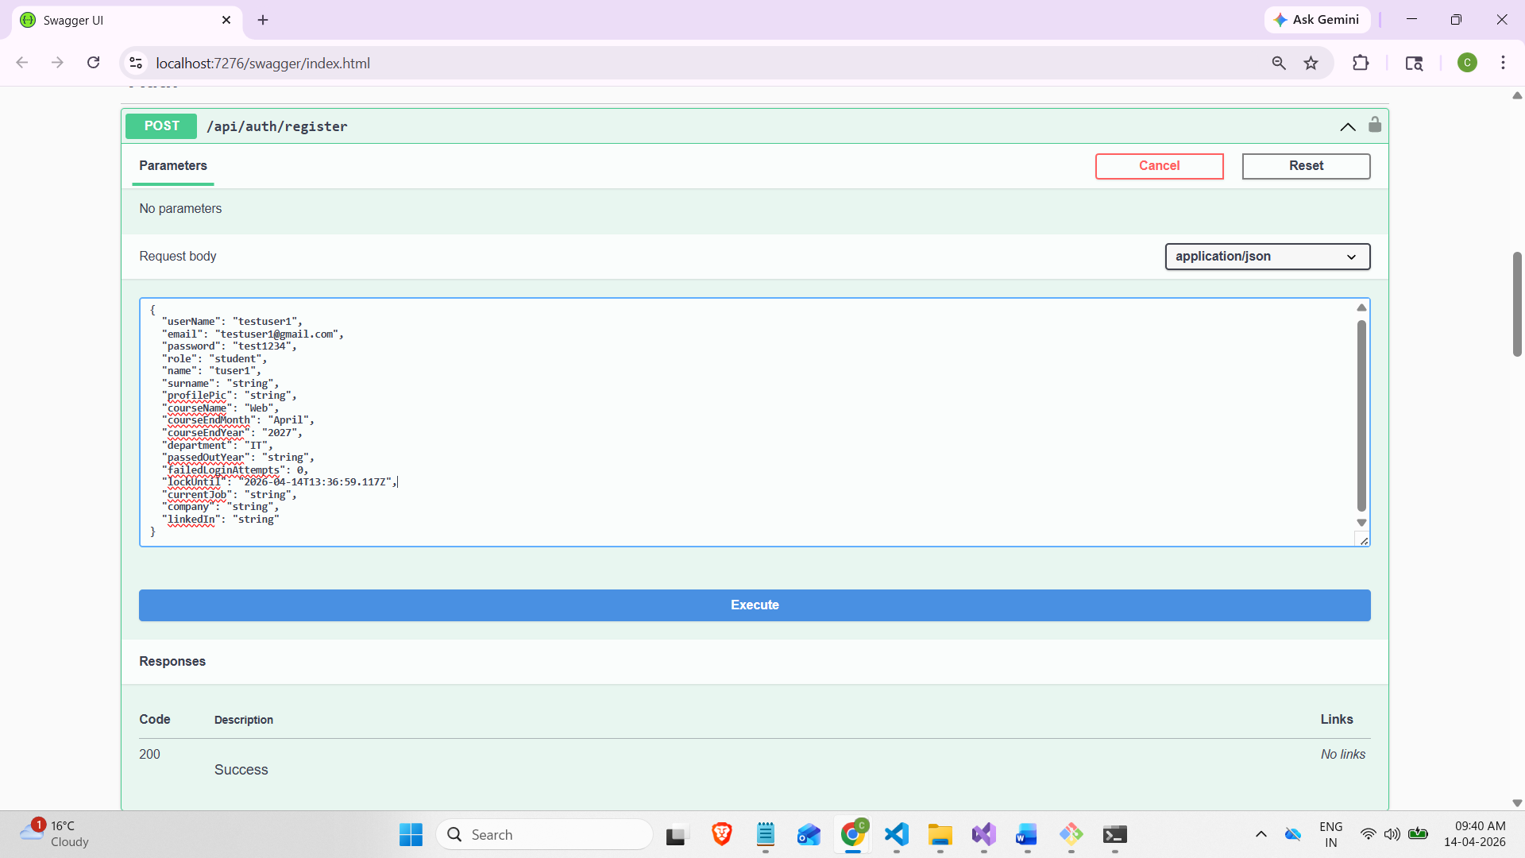

Response:
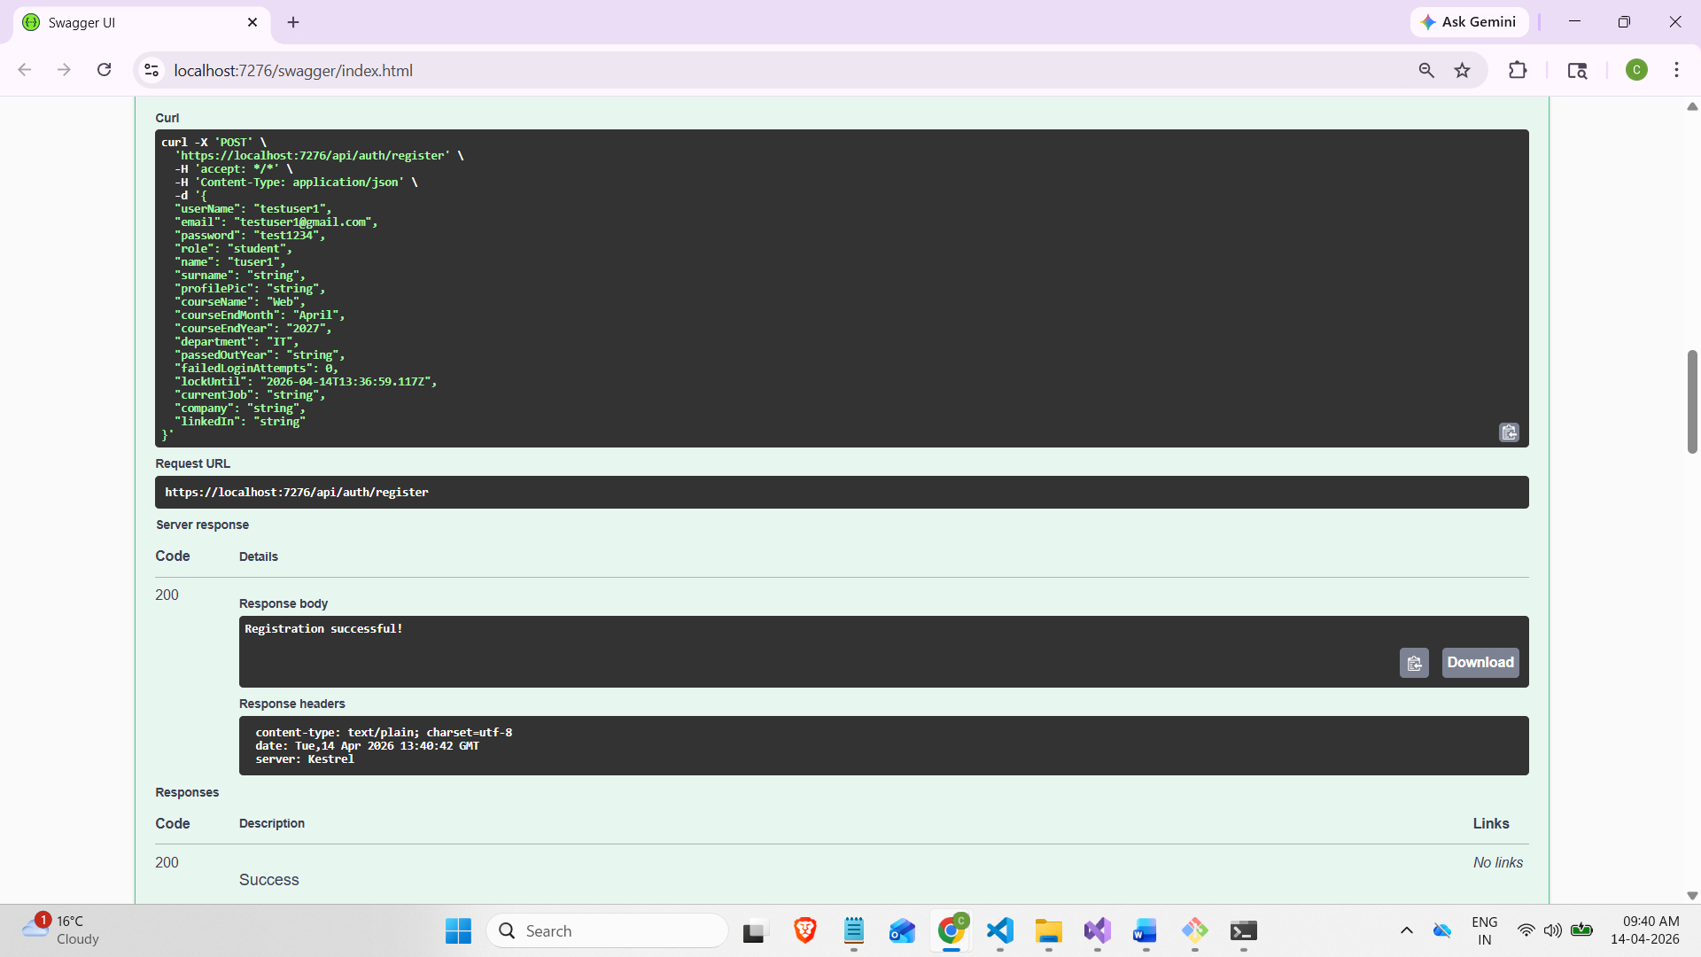

- Auth/login
Account locking feature: Wrong login credential:
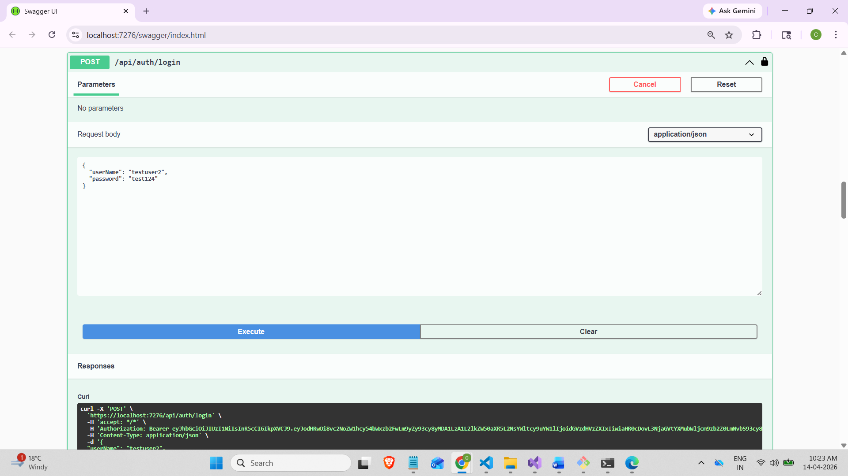

Response 1:
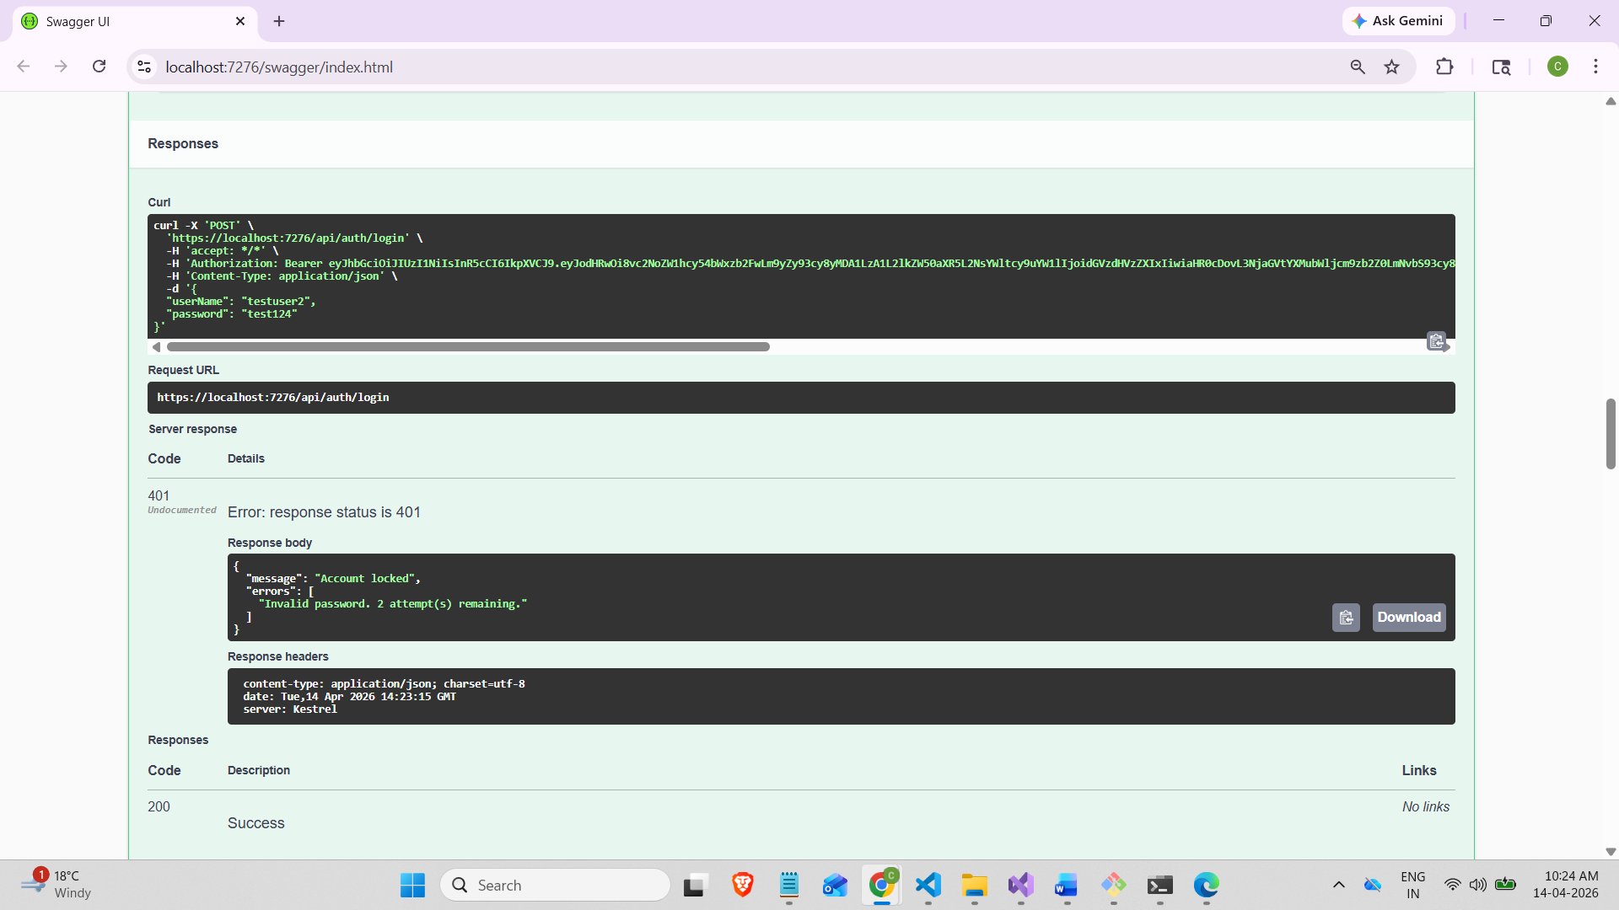

Response 2:
after 3 attempts: Account locked for 5hrs
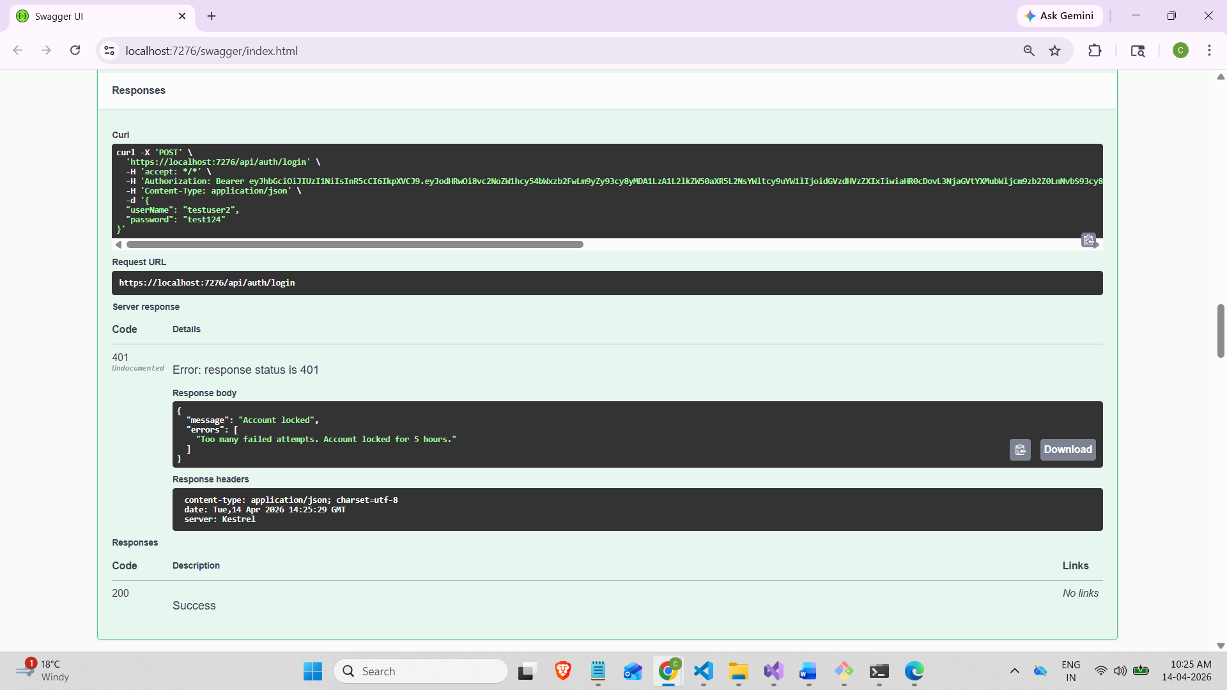

Correct credentials:
Request Body:
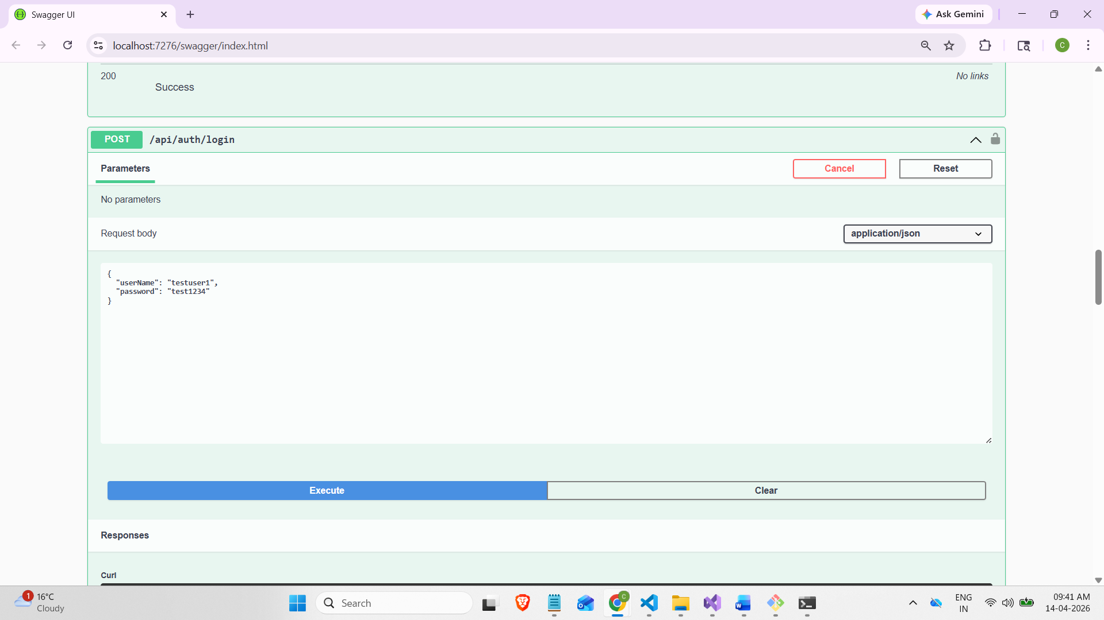

Response with JWT Token:
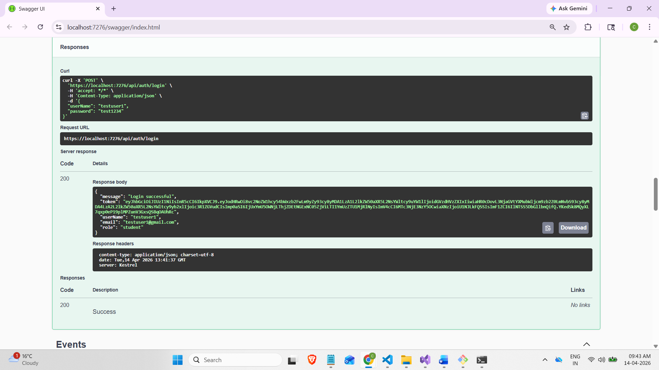

Adding JWT Tokens to perform the Testing:
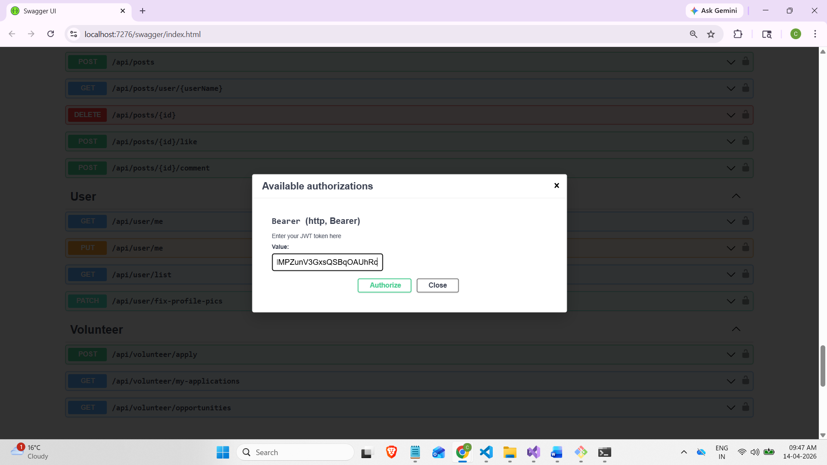
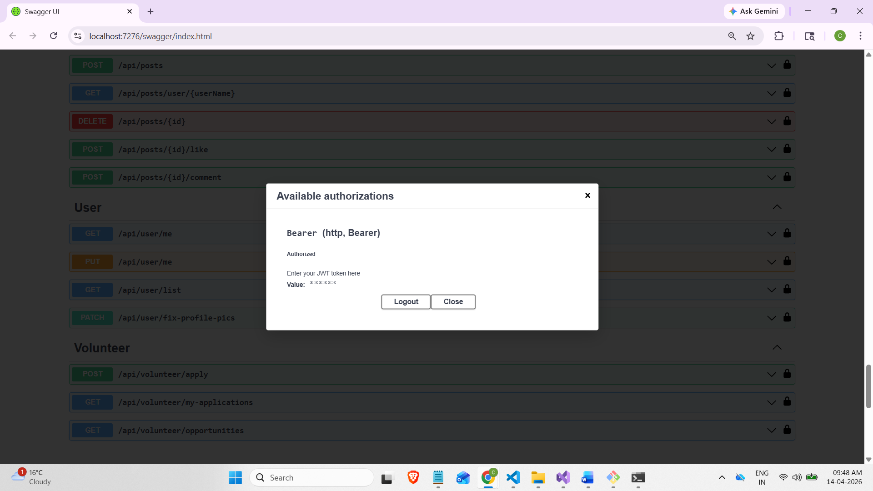

User Controller:
Get User/me

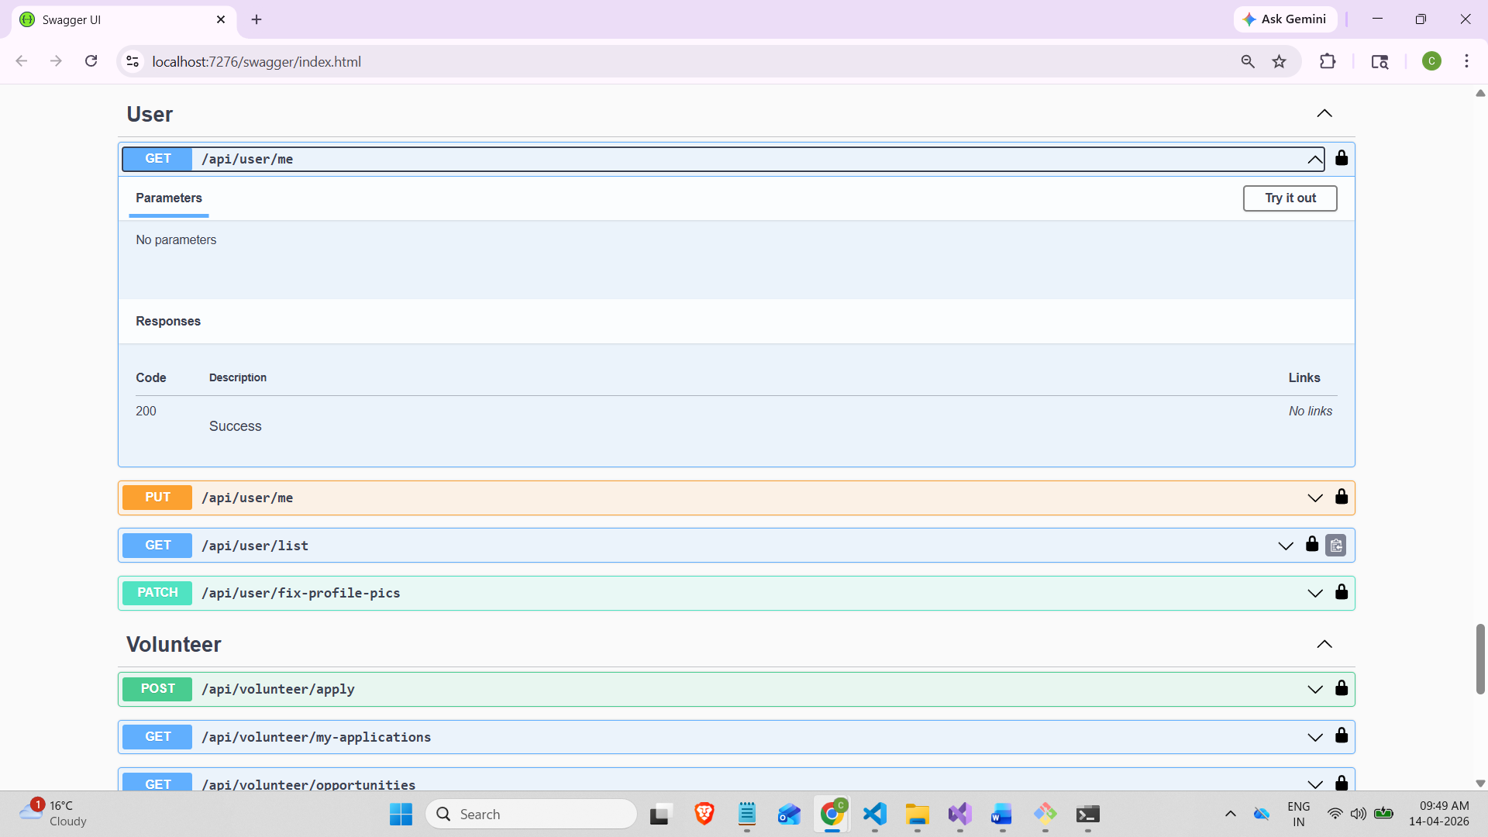

Response:
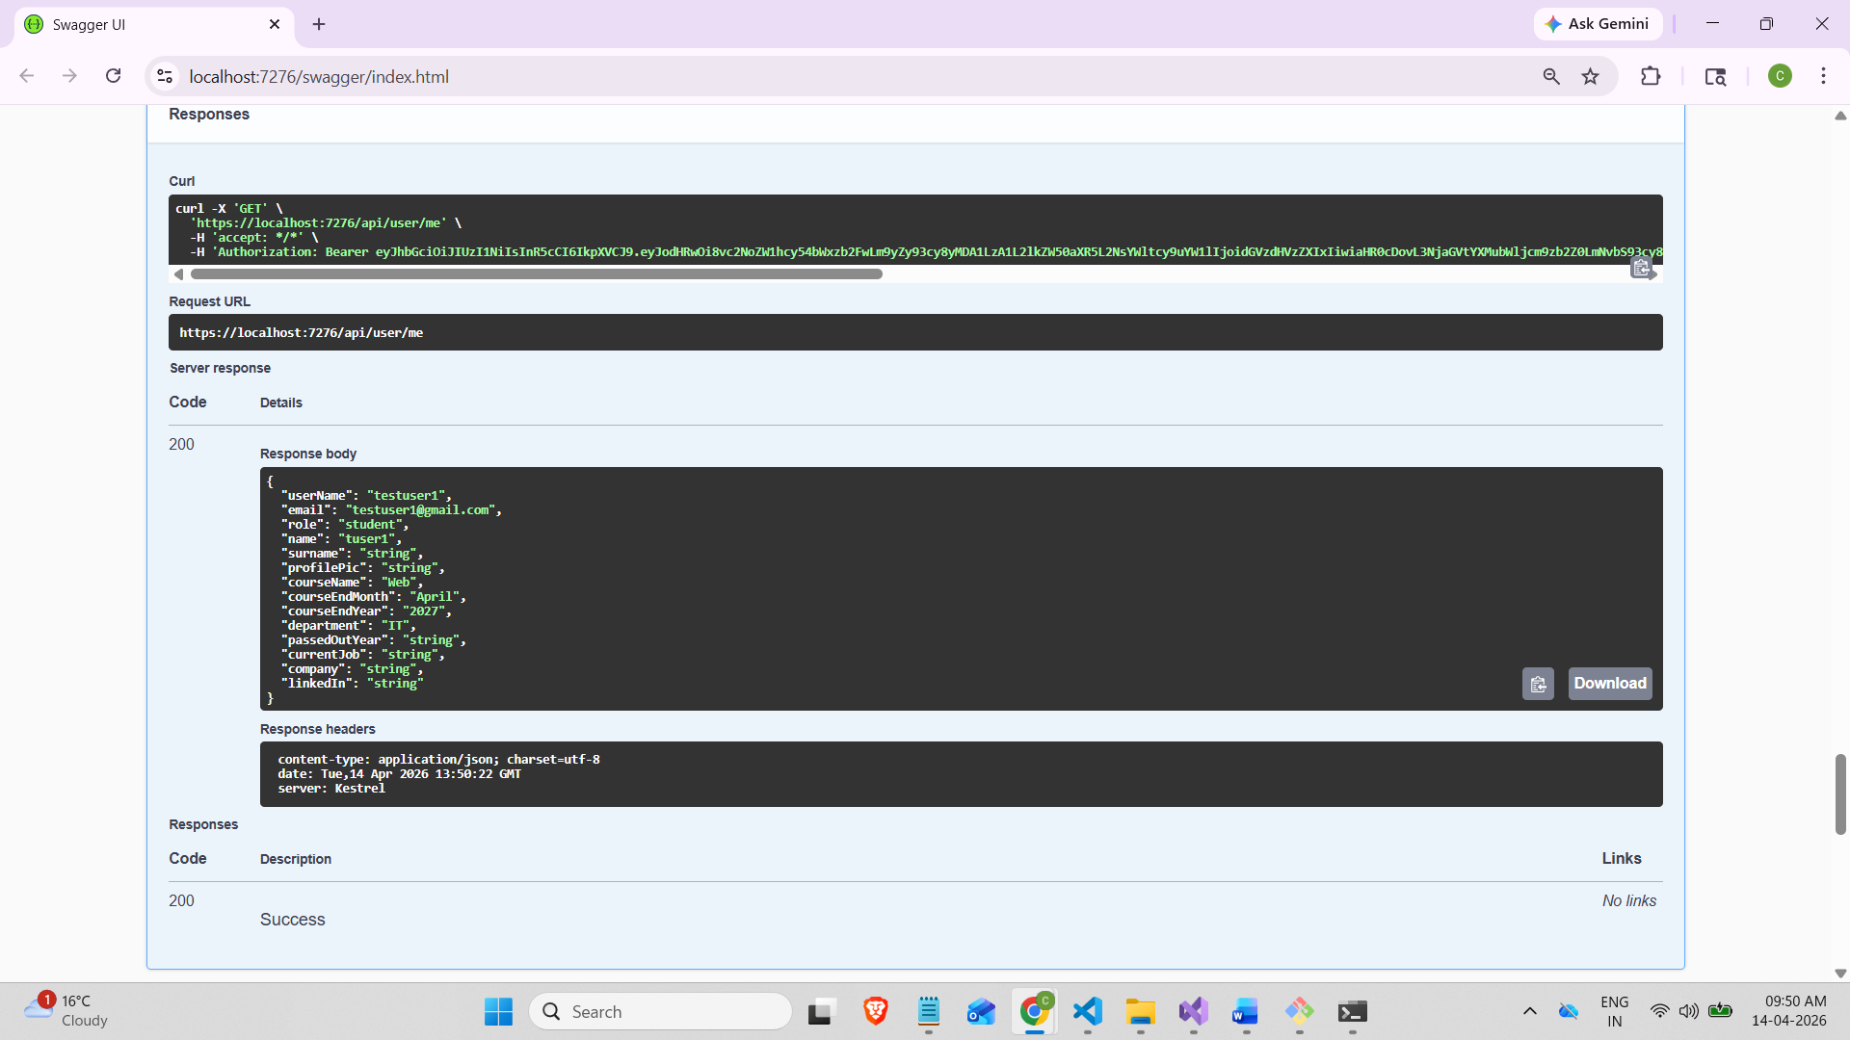

- Put/api/user/me
updating some of the records
Request body:
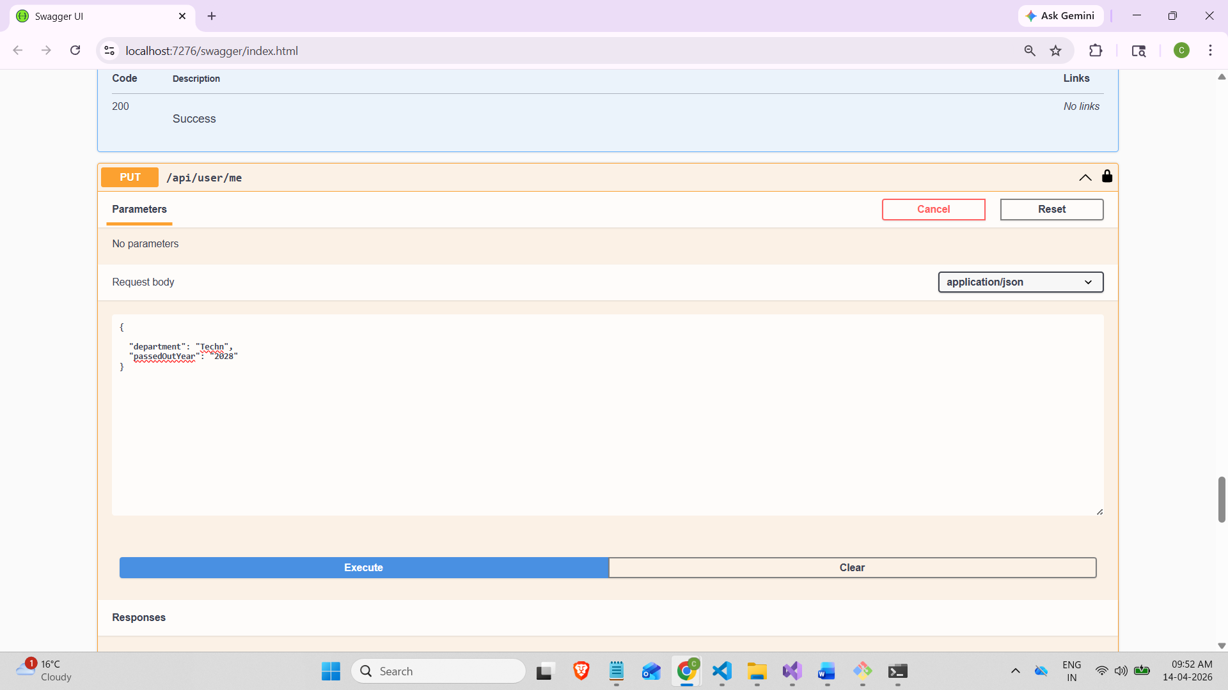

Response:
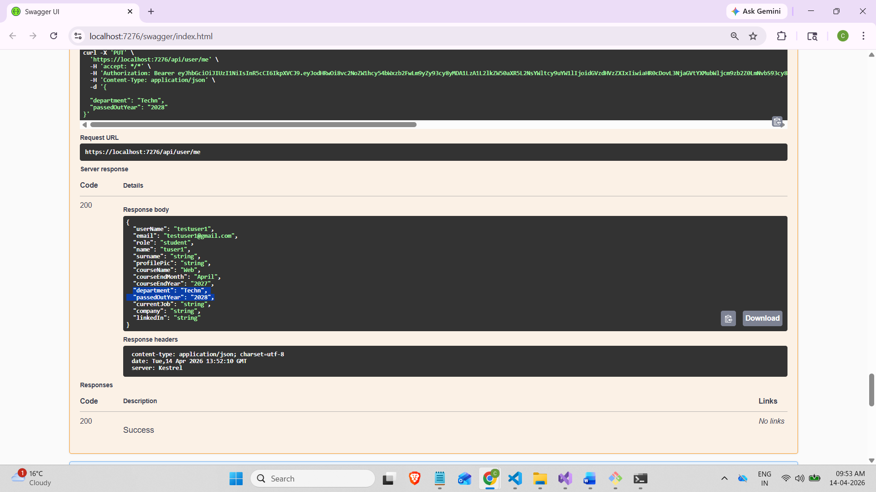

- Get /api/user/list
it will return all the details based on the role
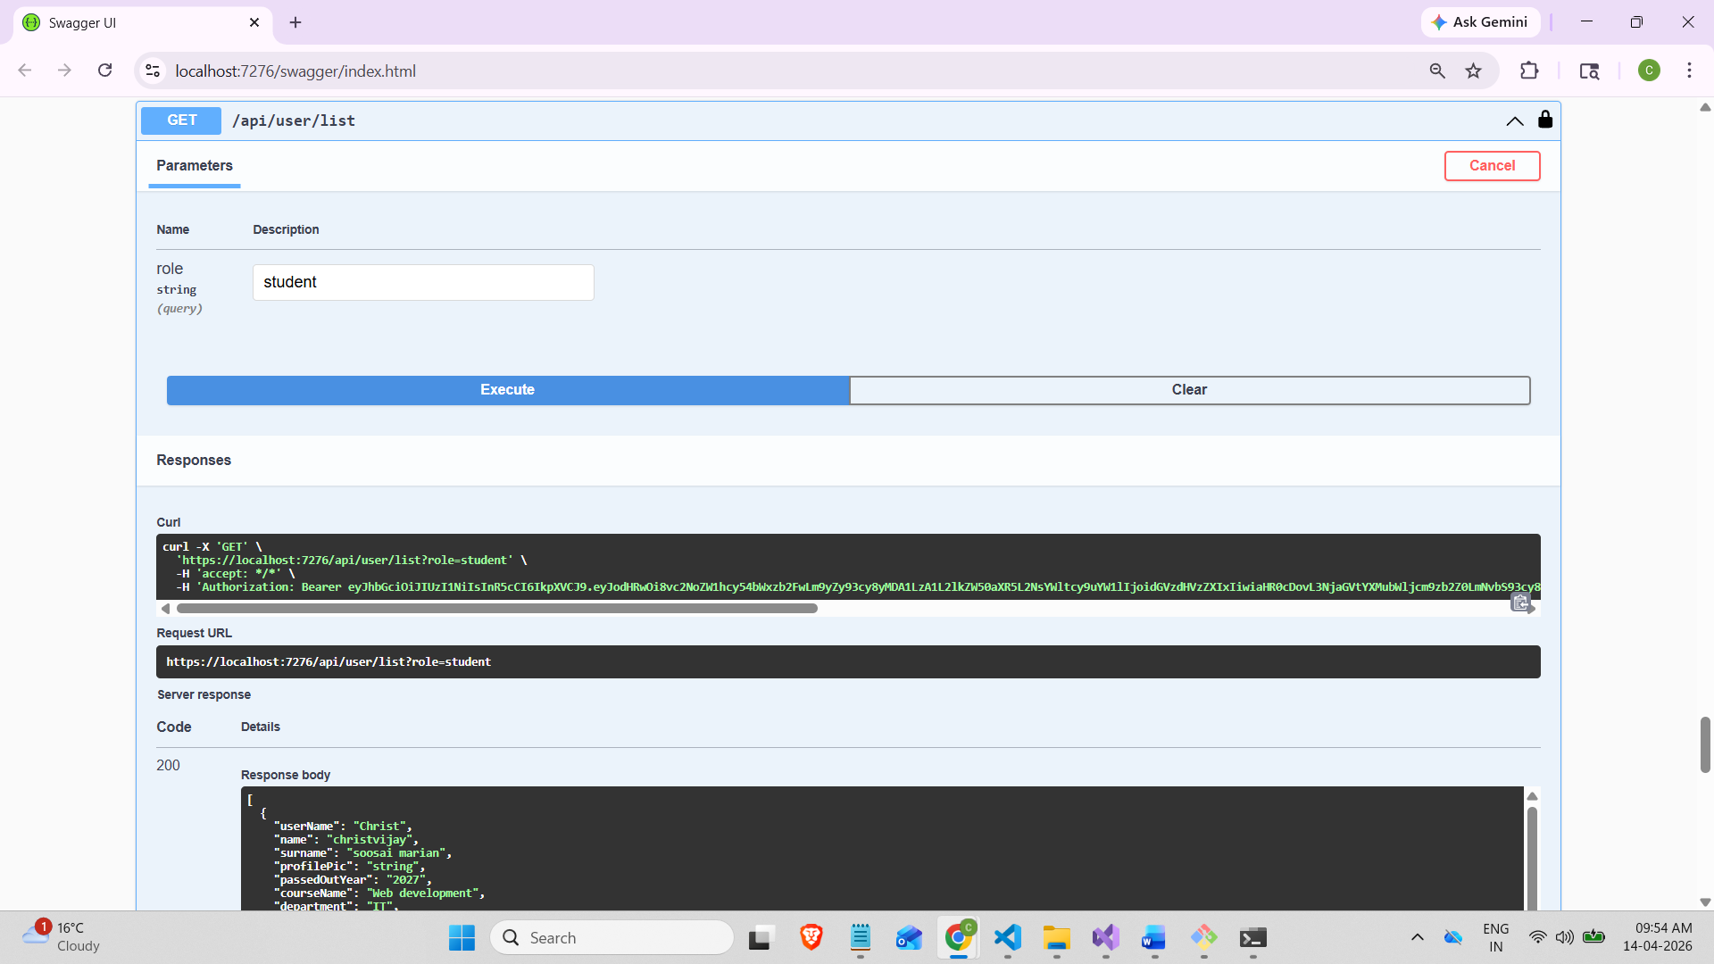
Response:
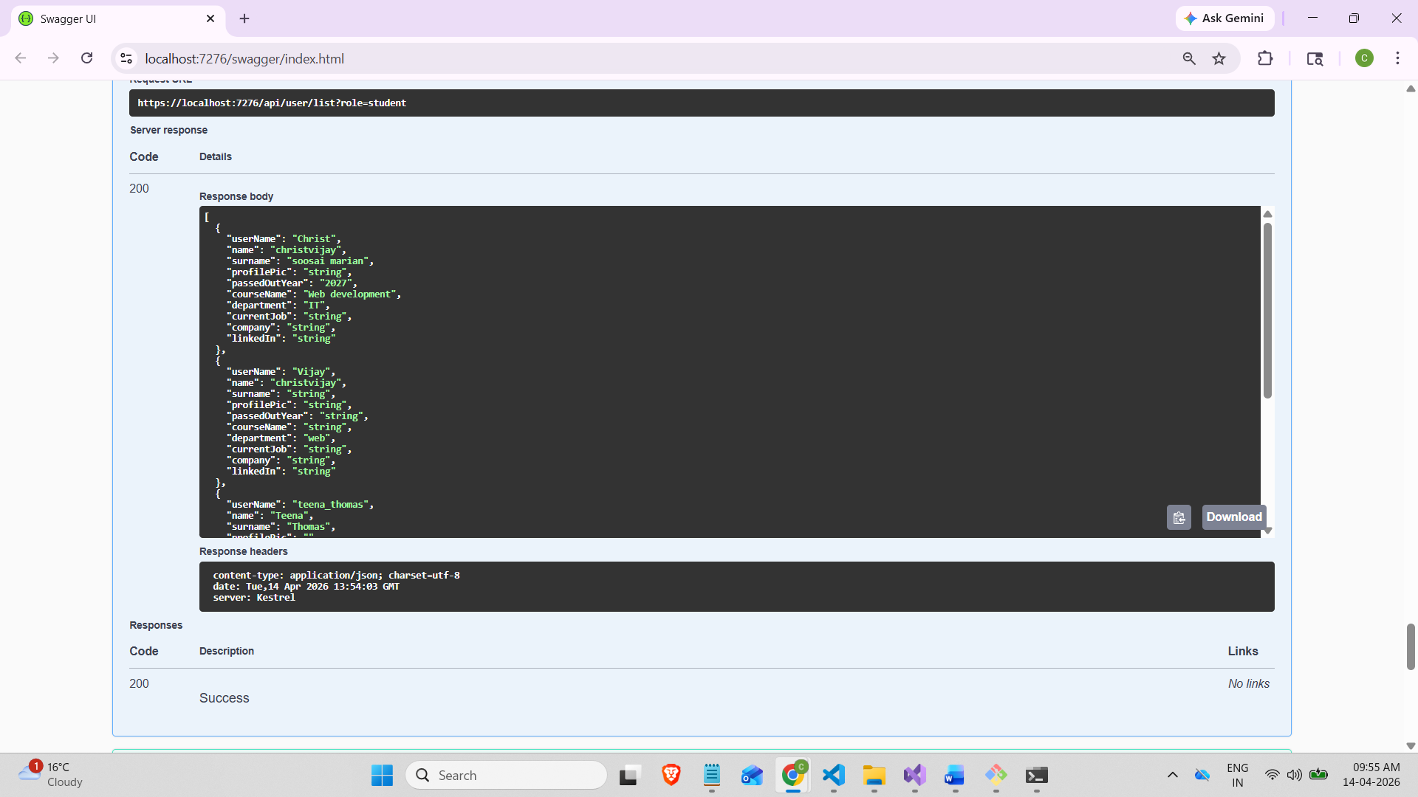
Volunteer Controller:
1.) Get/api/volunteer/opportunities
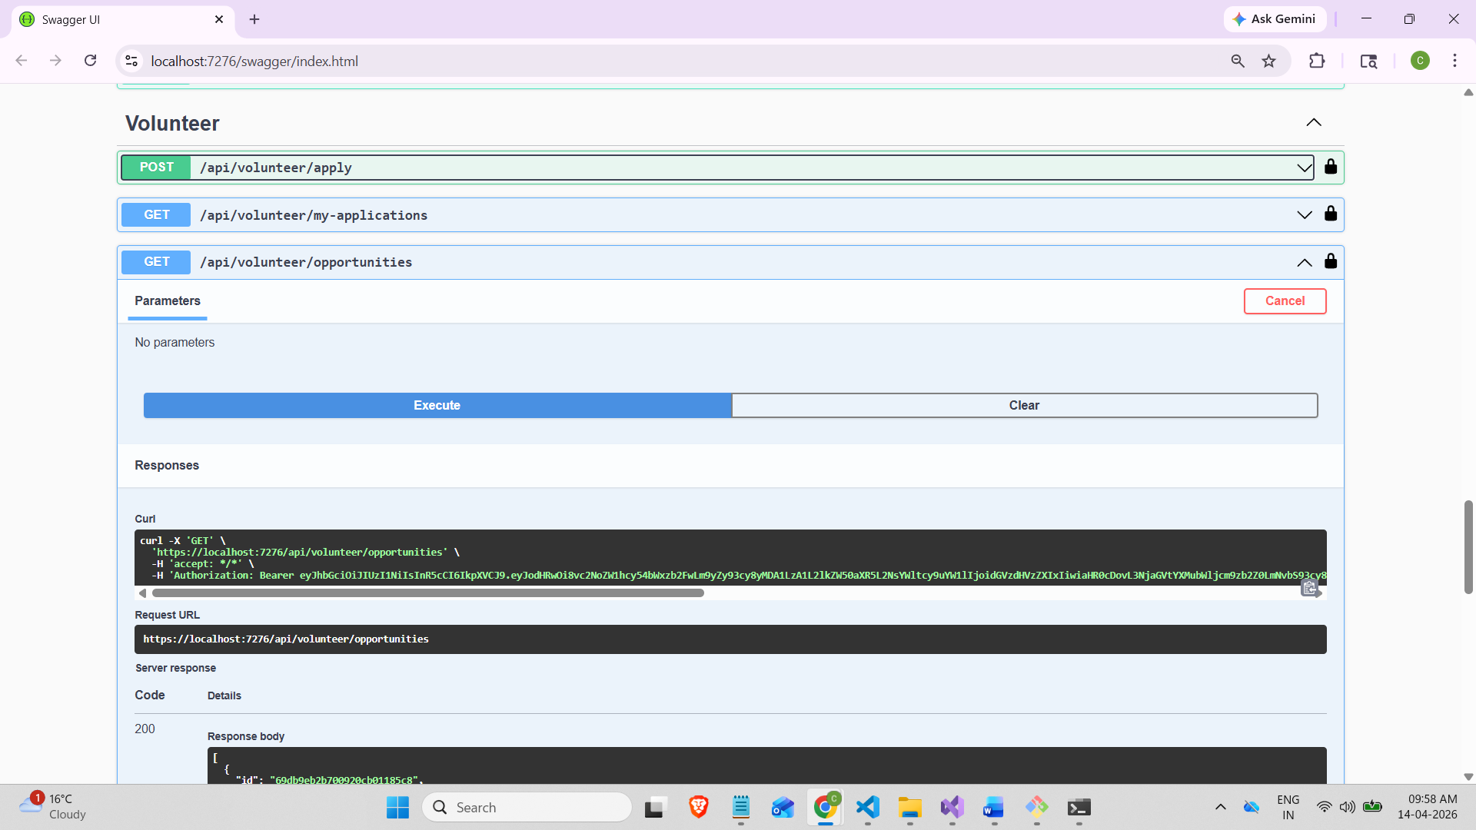

Response:
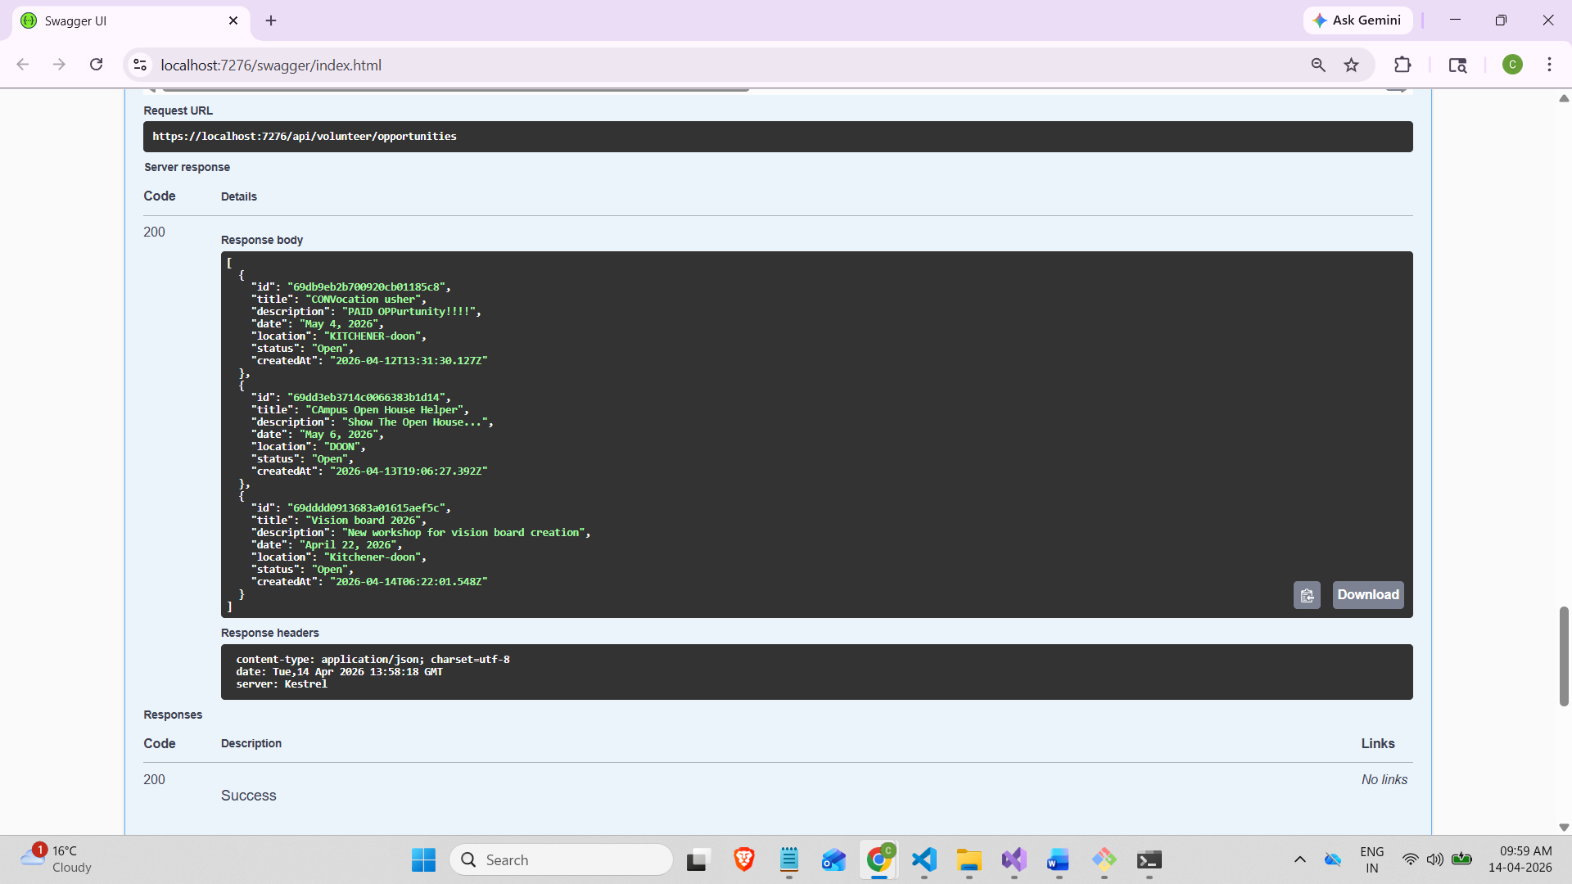

2.) Post/api/volunteer/apply
Applying for volunteer
Request body: Adding the opportunityId and Title from previous Get API
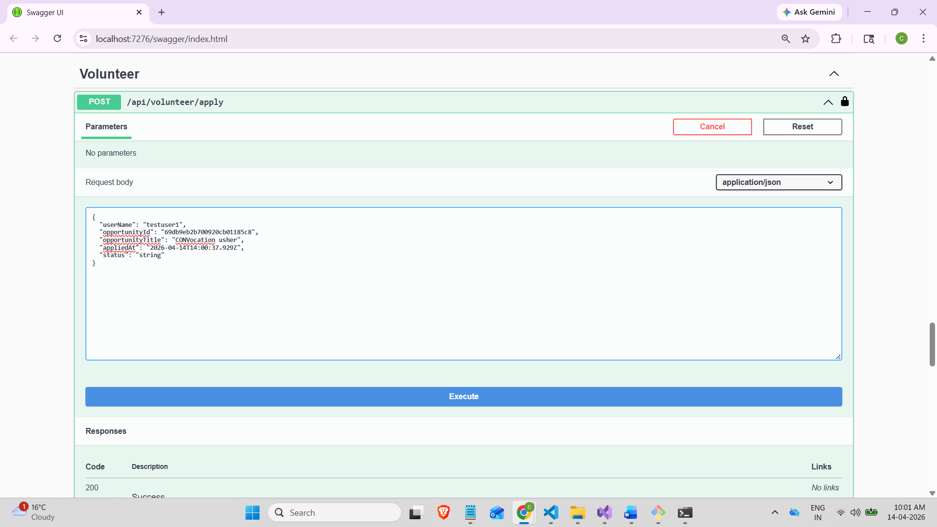

Response:
Status: Pending
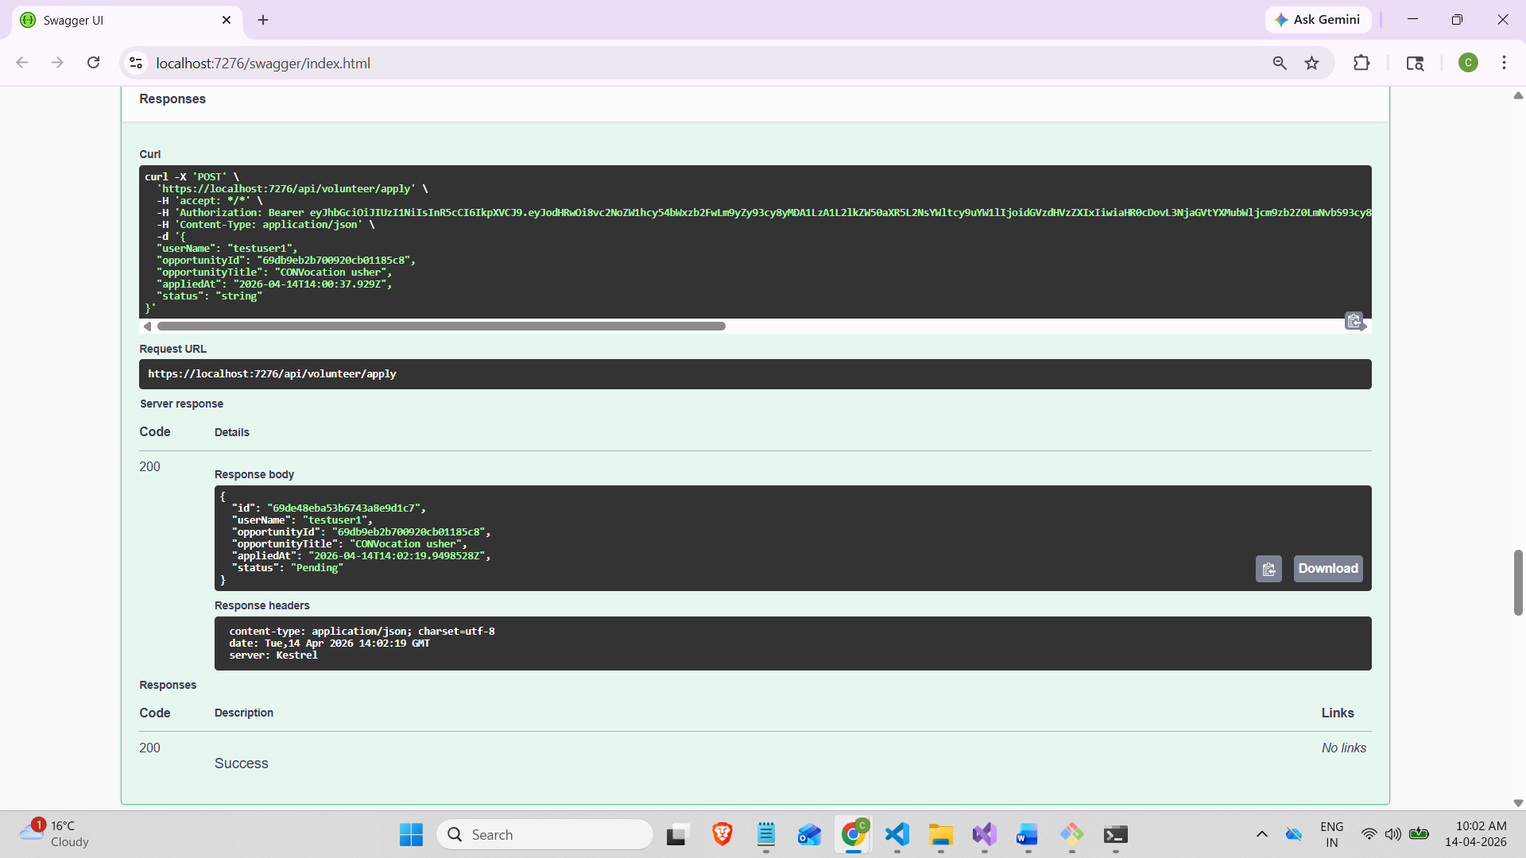

3.) Get/api/volunteer/my-application
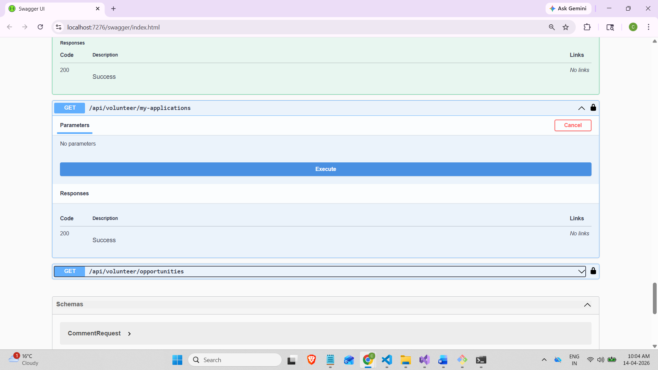

Response:

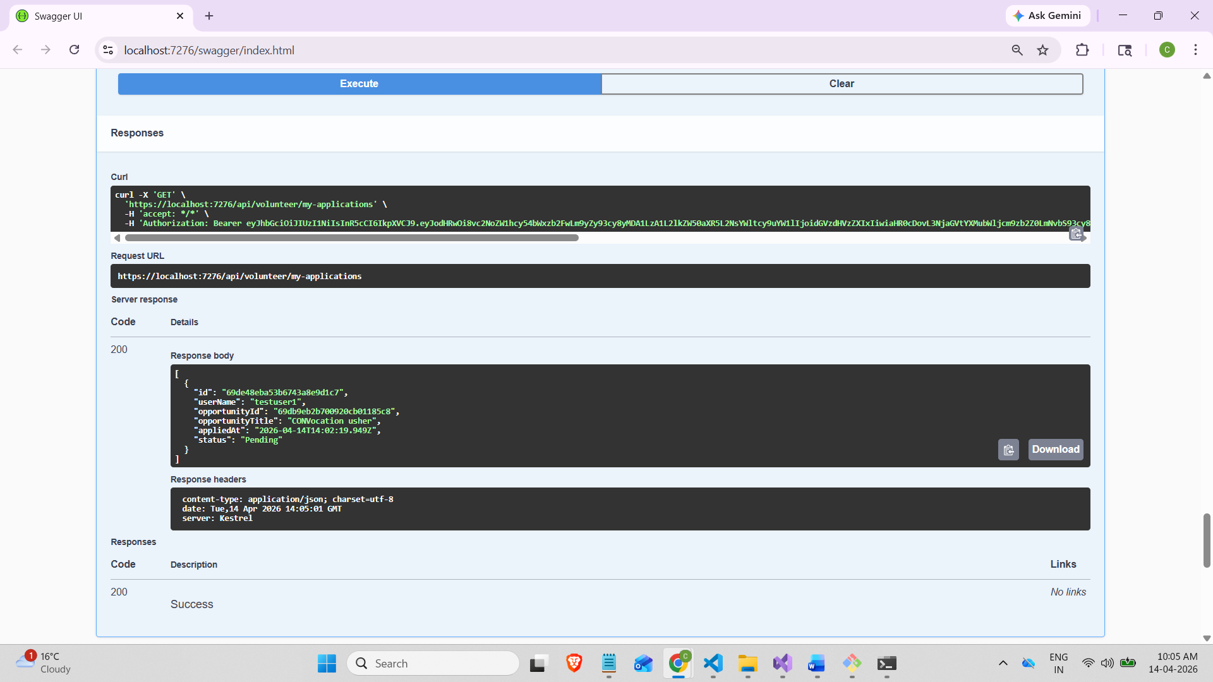

Logged in as an admin
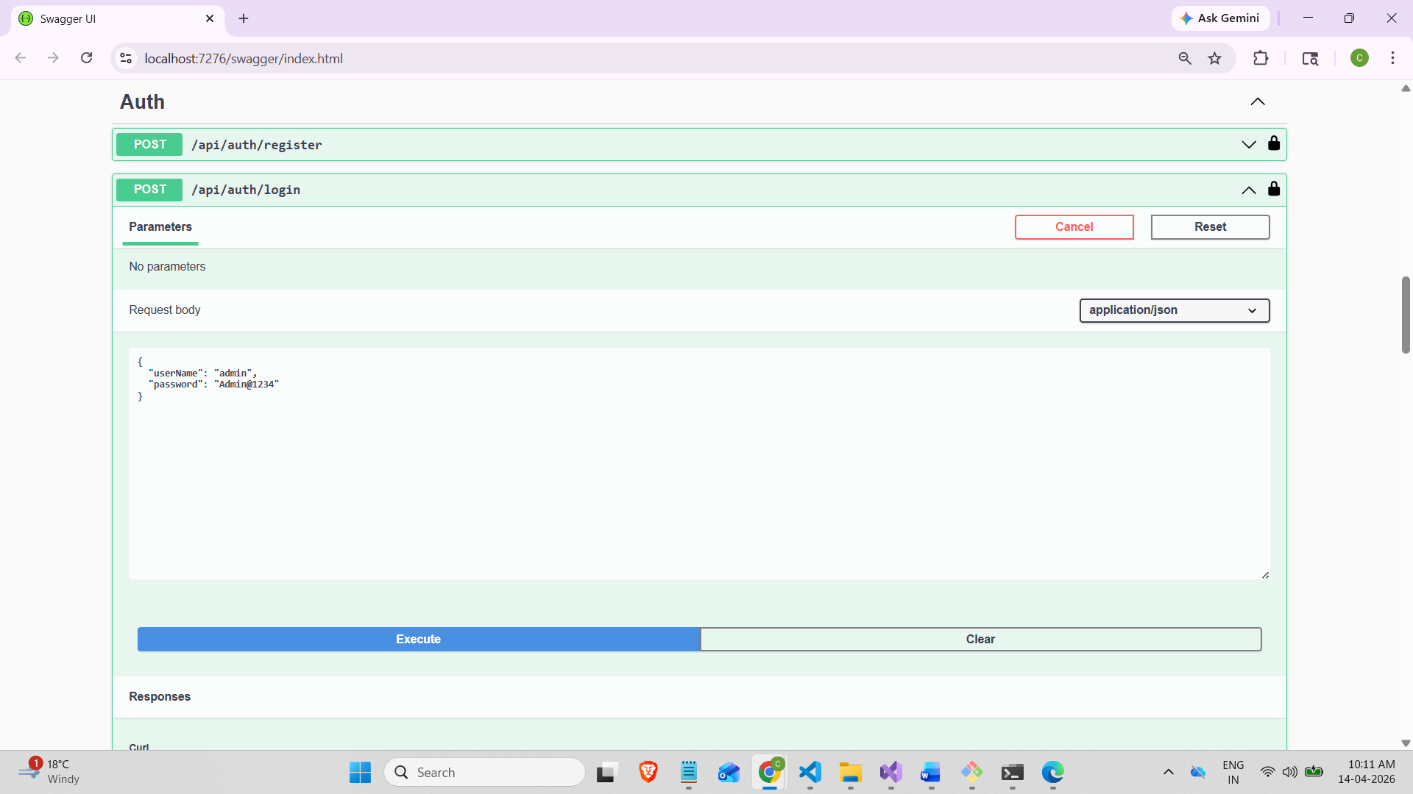

Admin Controller:
- PATCH/api/admin/volunteer-application/{id}/status:

Request body:
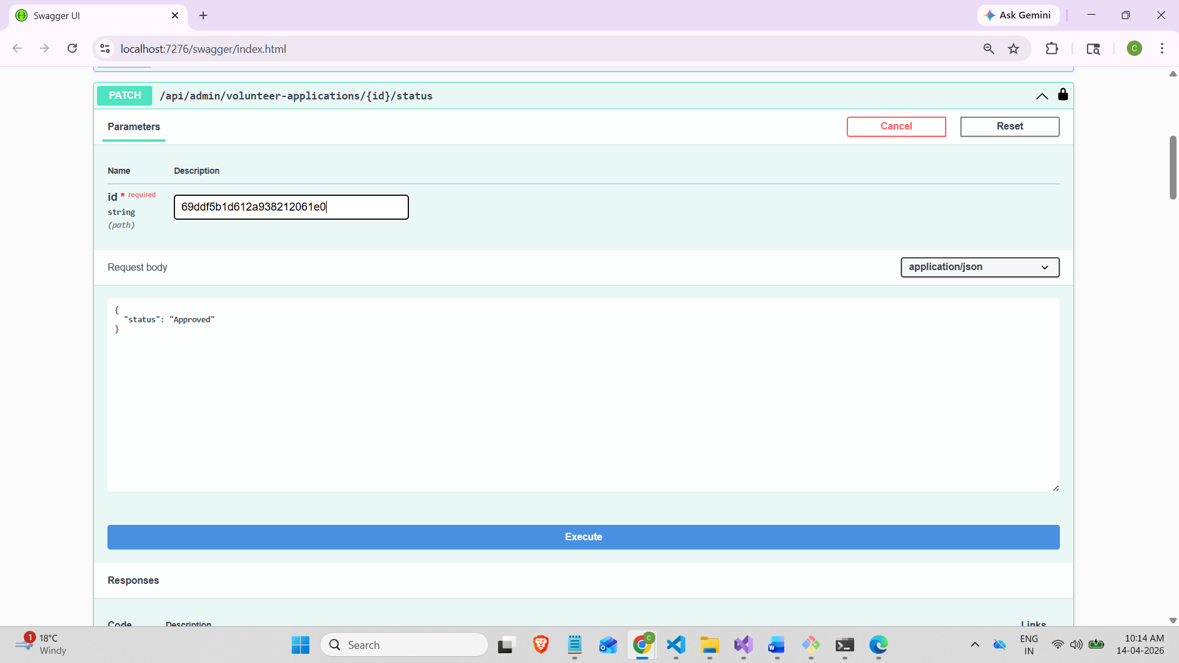

Response body:
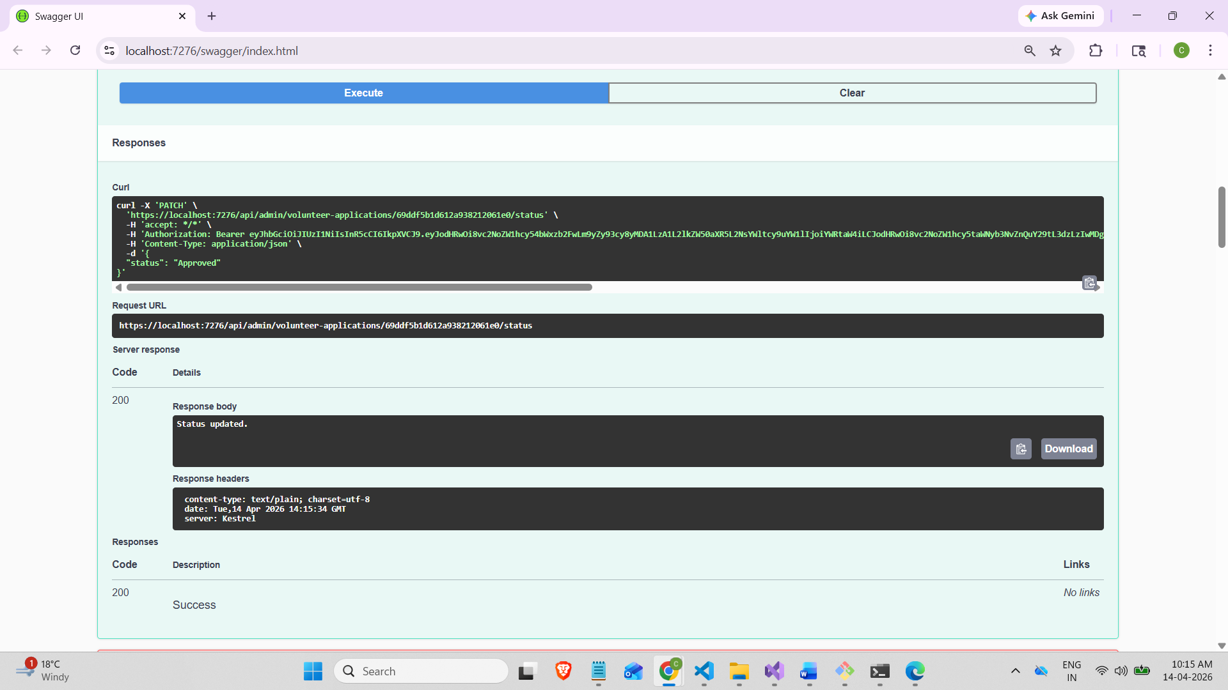

- Get/api/admin/volunteer-application
We can see the status of users:
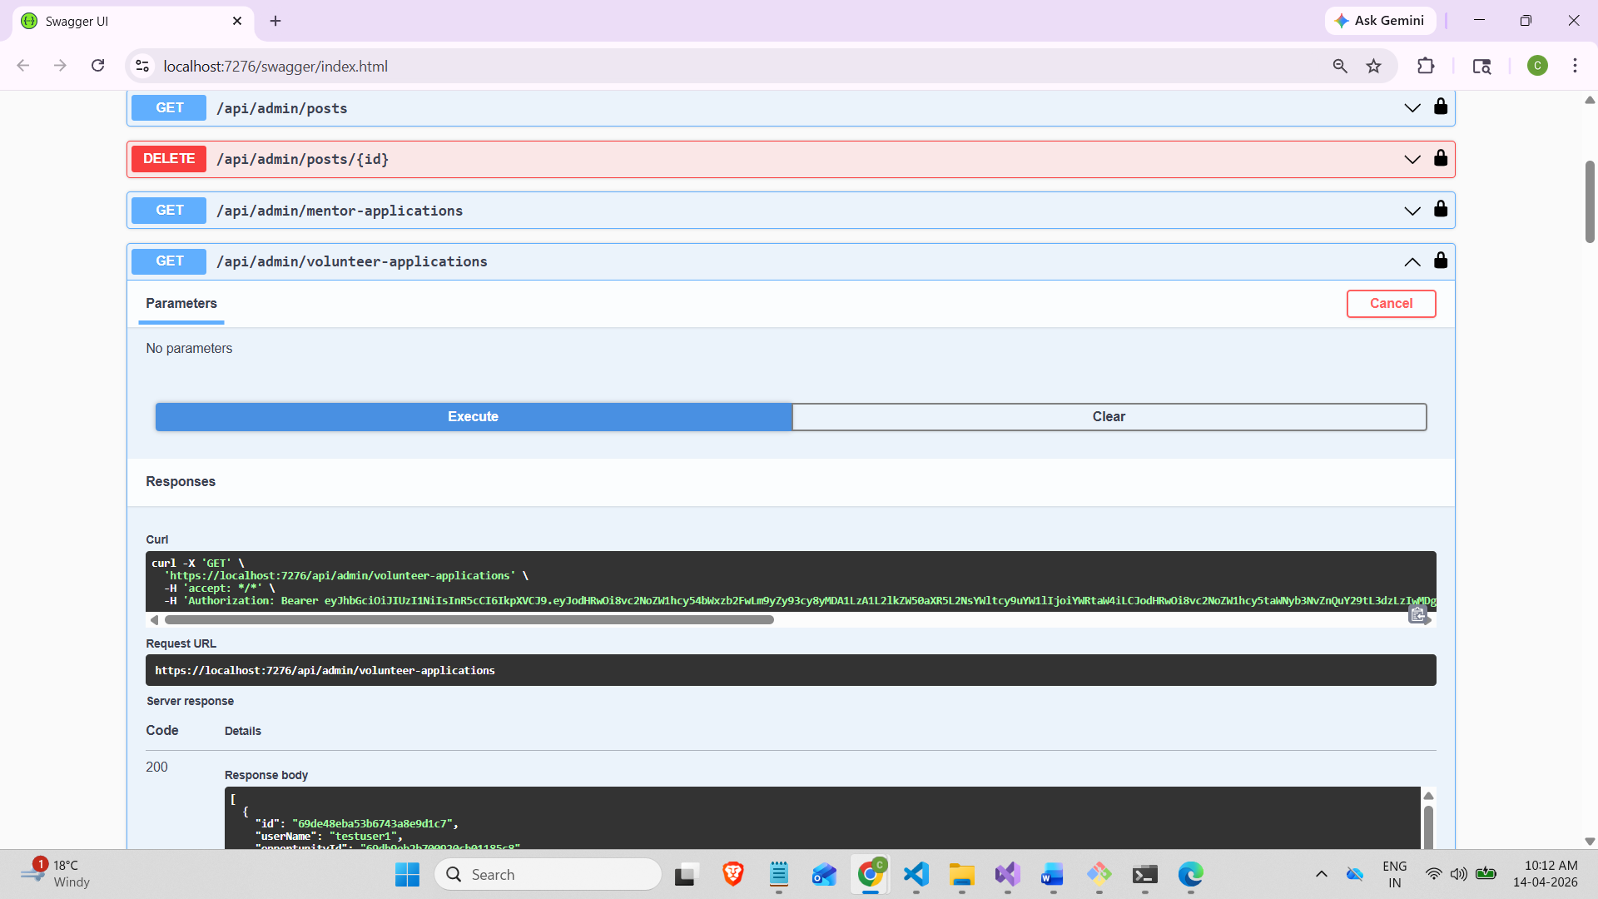

Response:
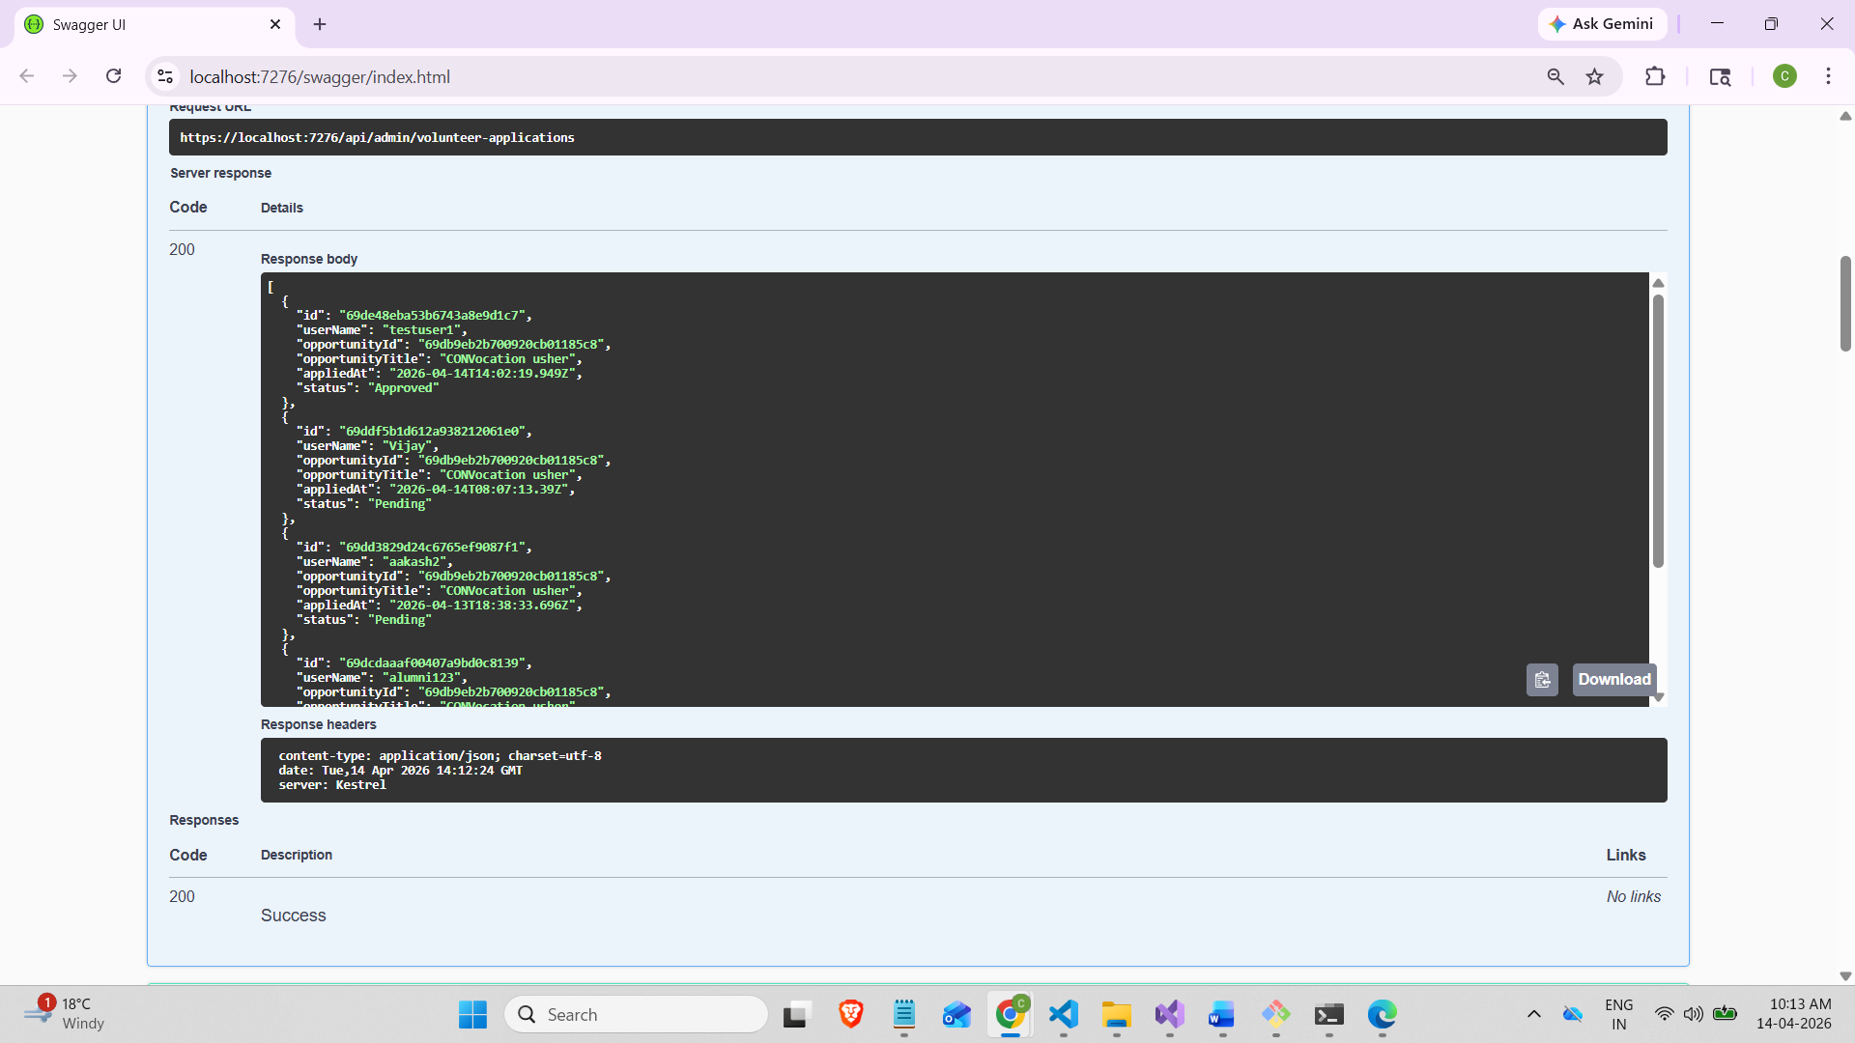
Now log in back as a TestUser1:
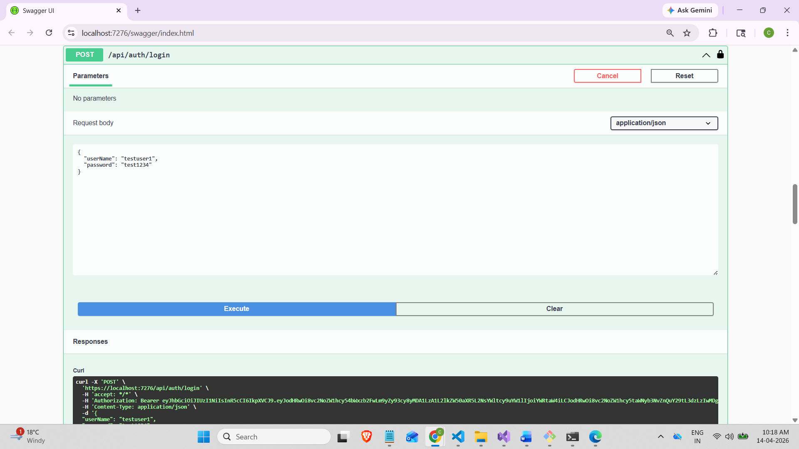

In Get/api/volunteer/my-application: we can see the response updated status as Approved
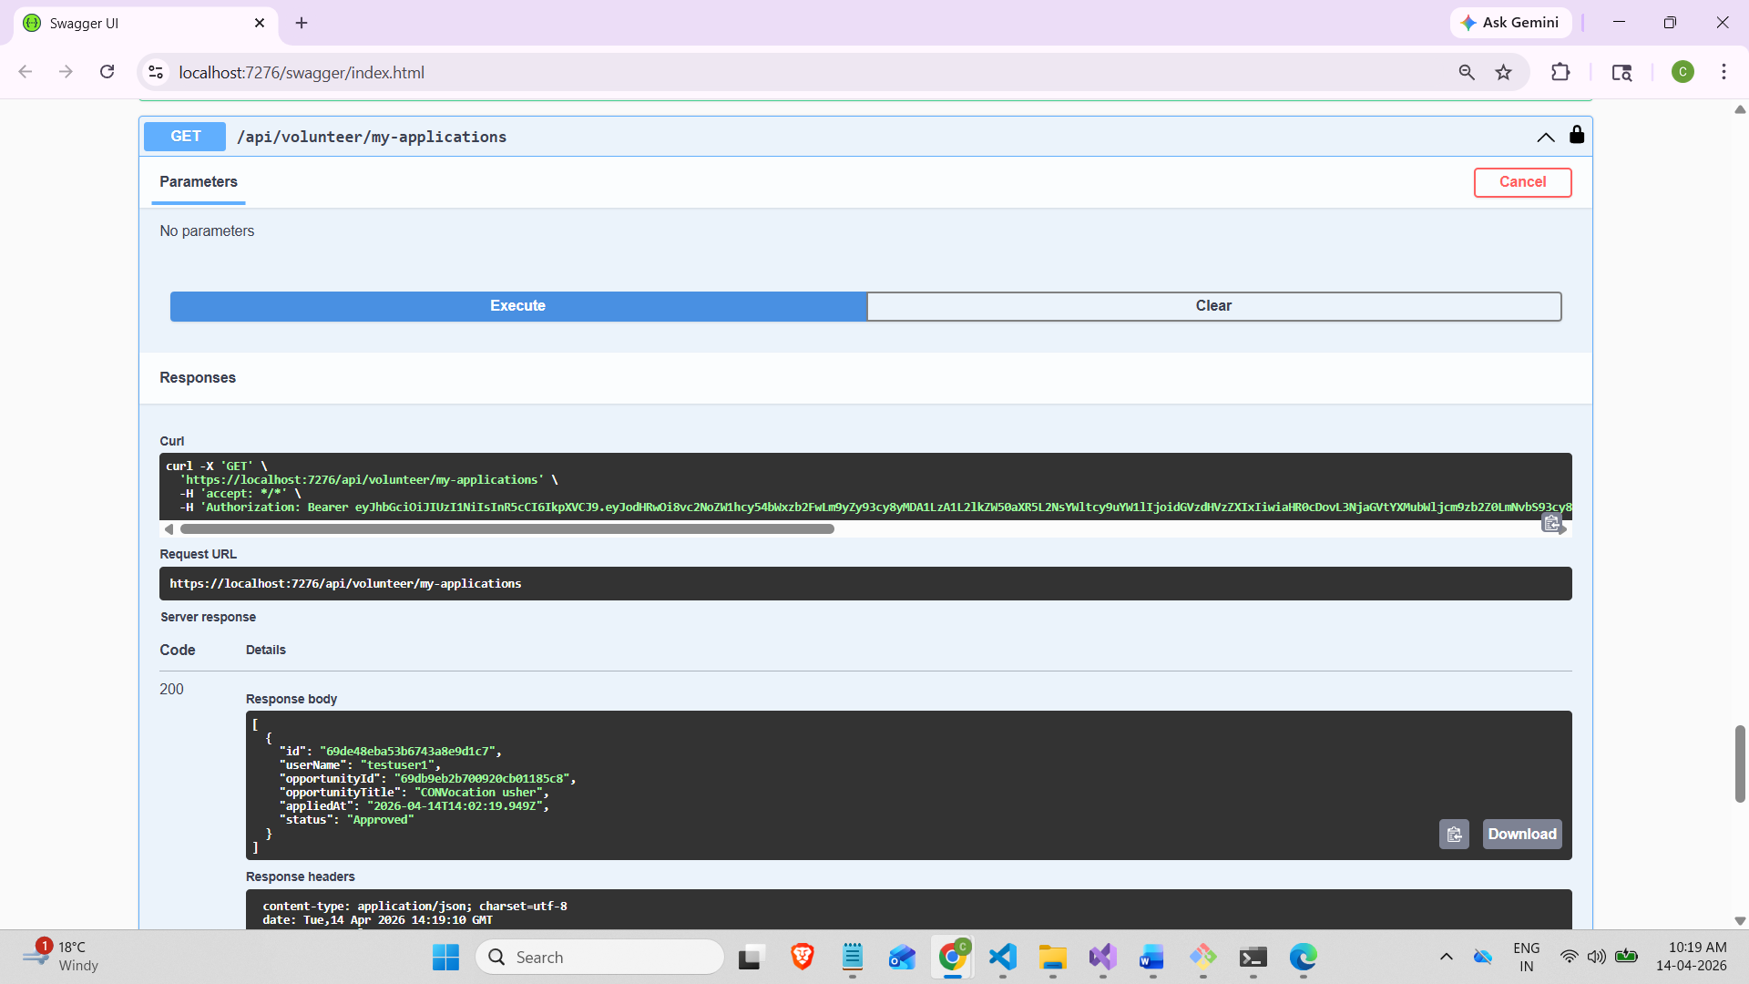

Event Services:
Get events:
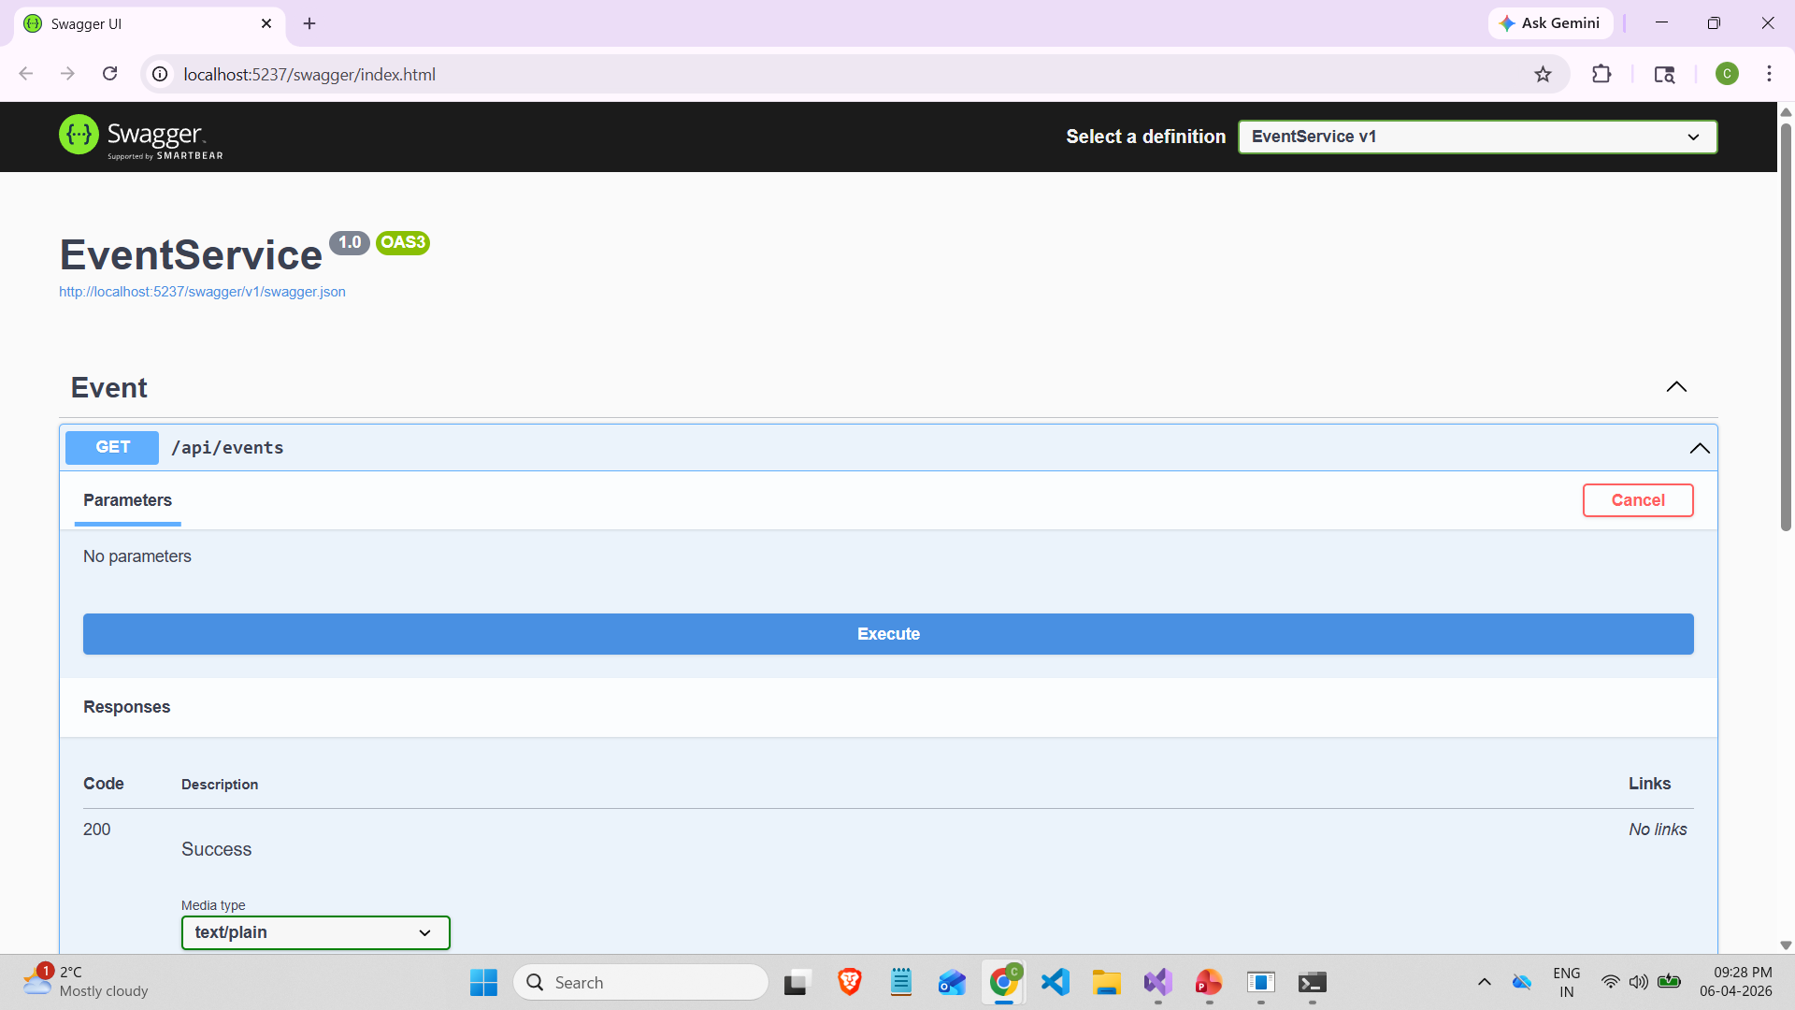

Response:
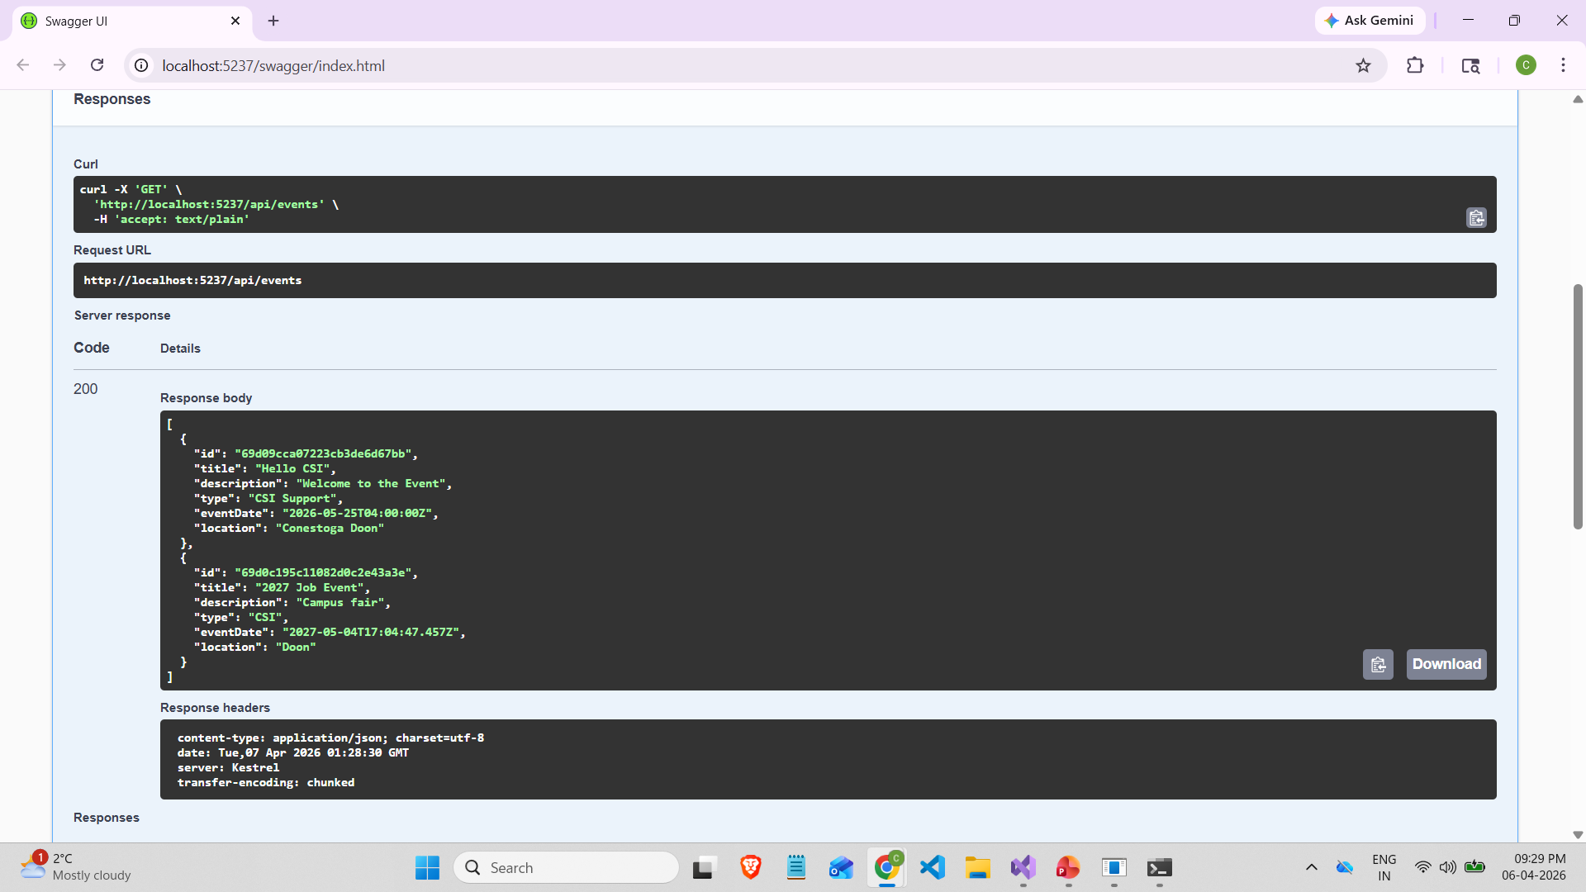

Post Event:
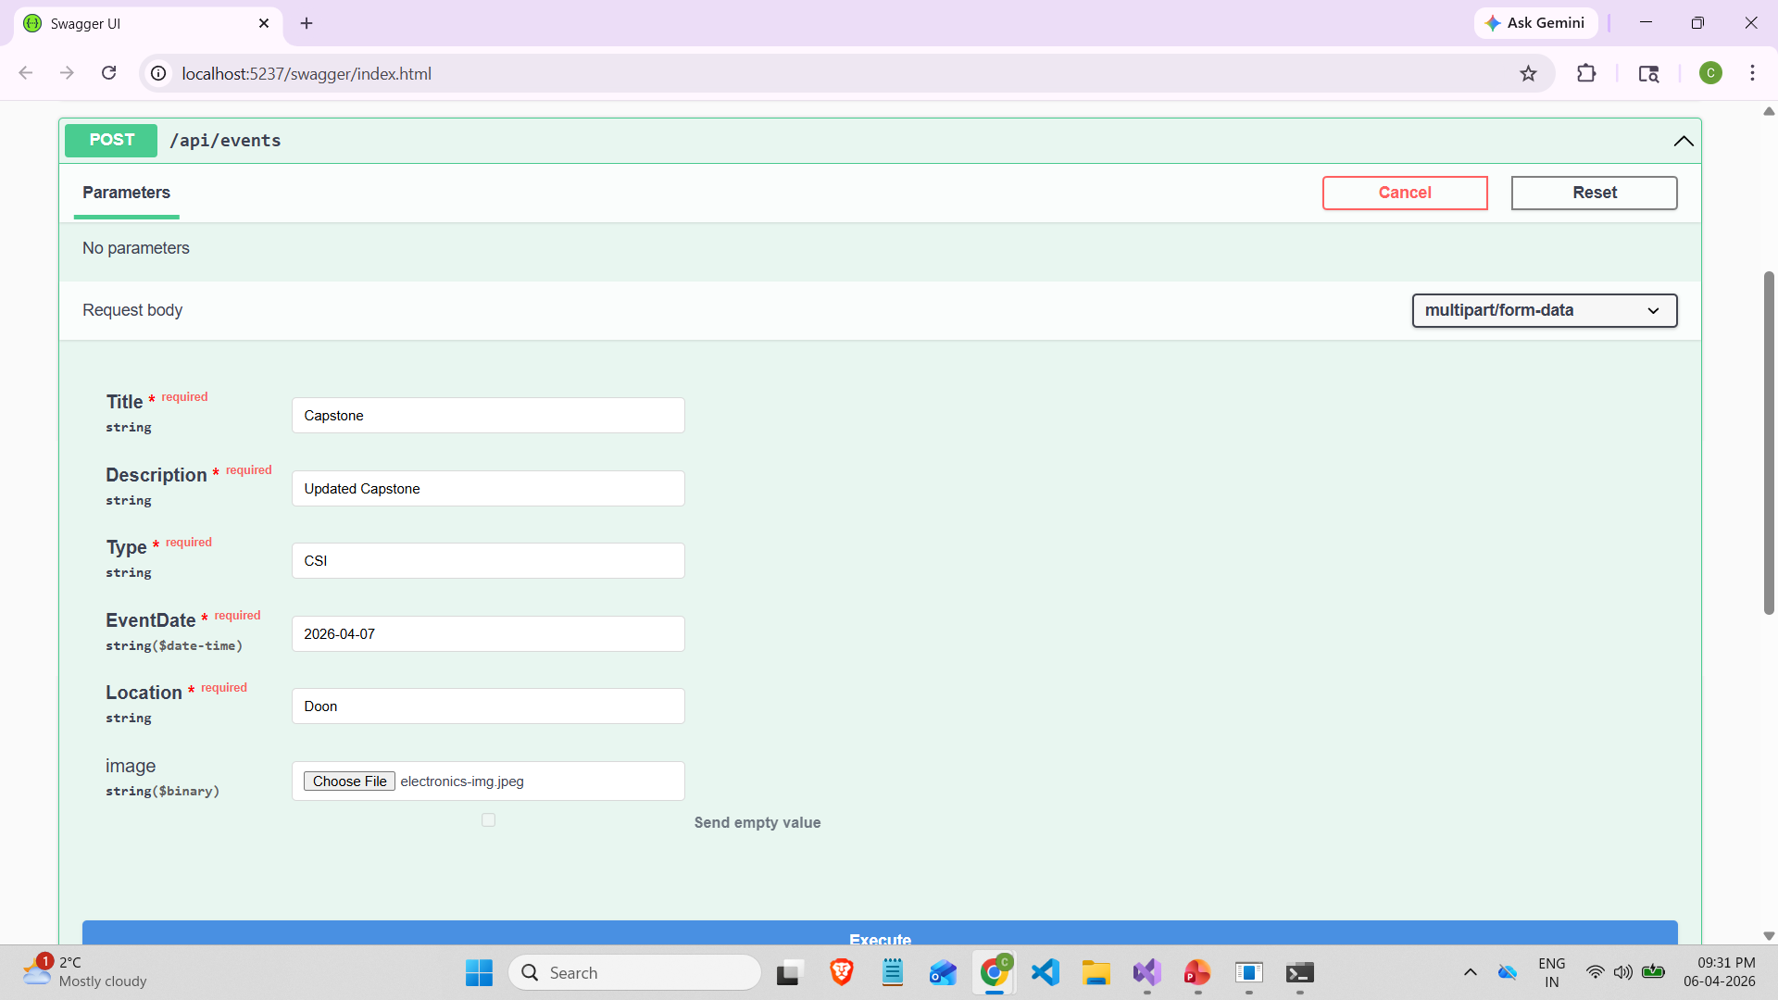

Response:

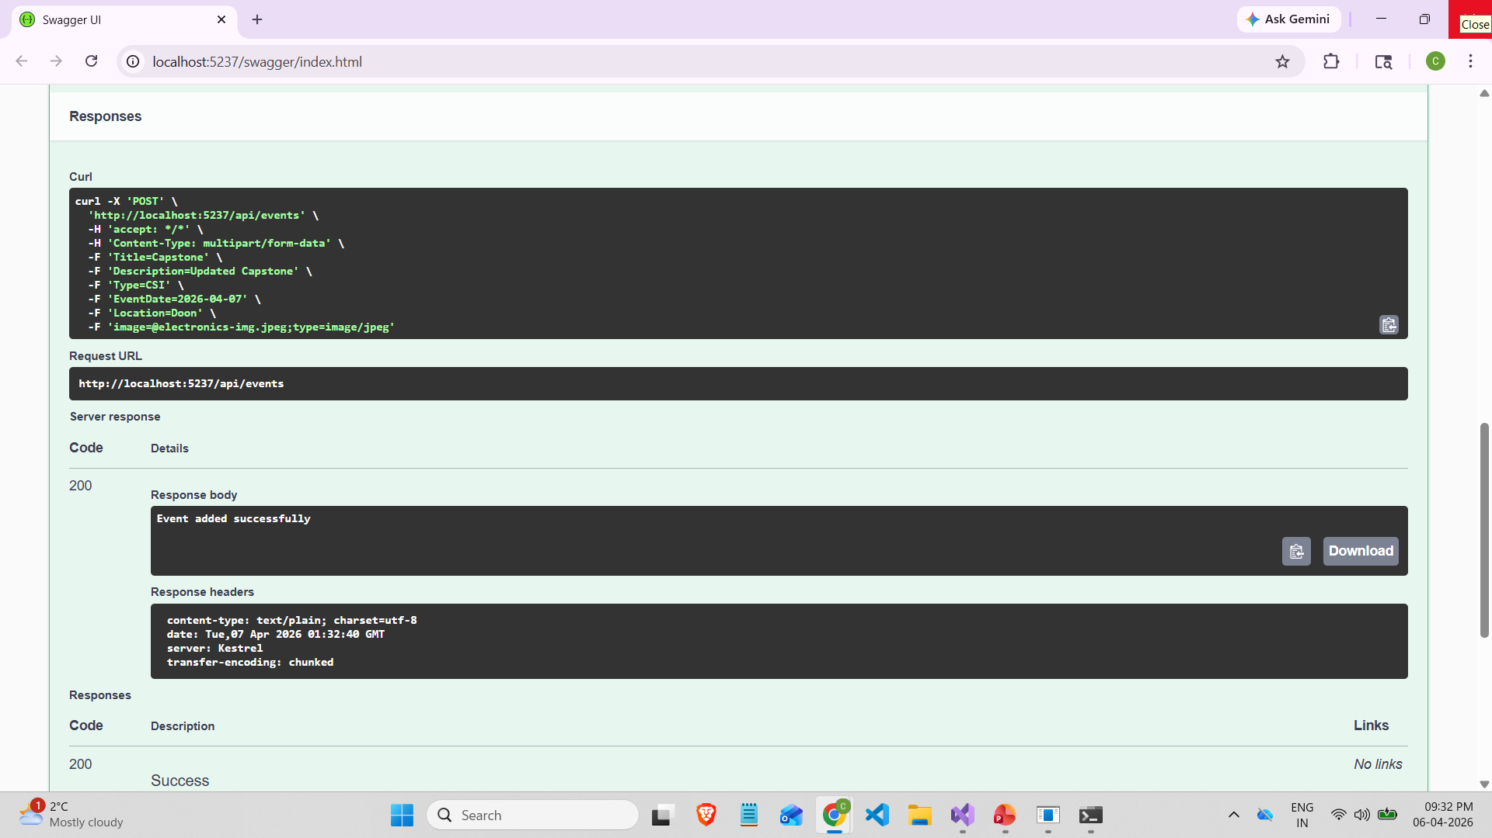

Get event by ID:
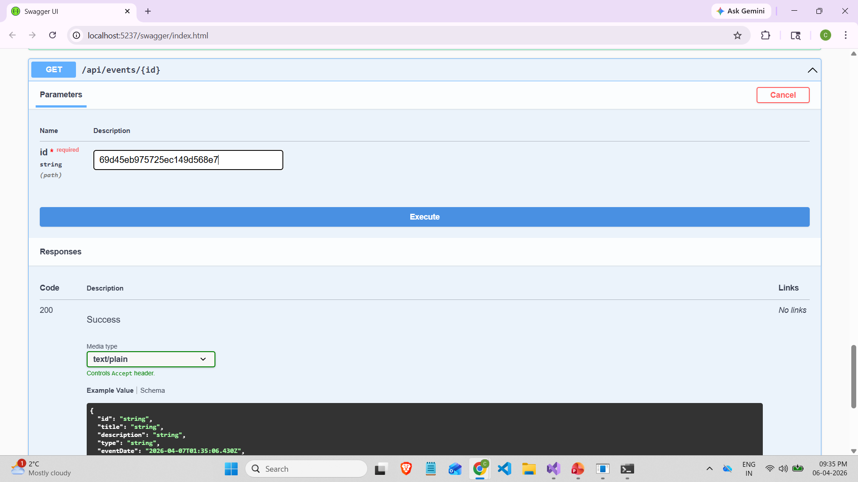

Response:
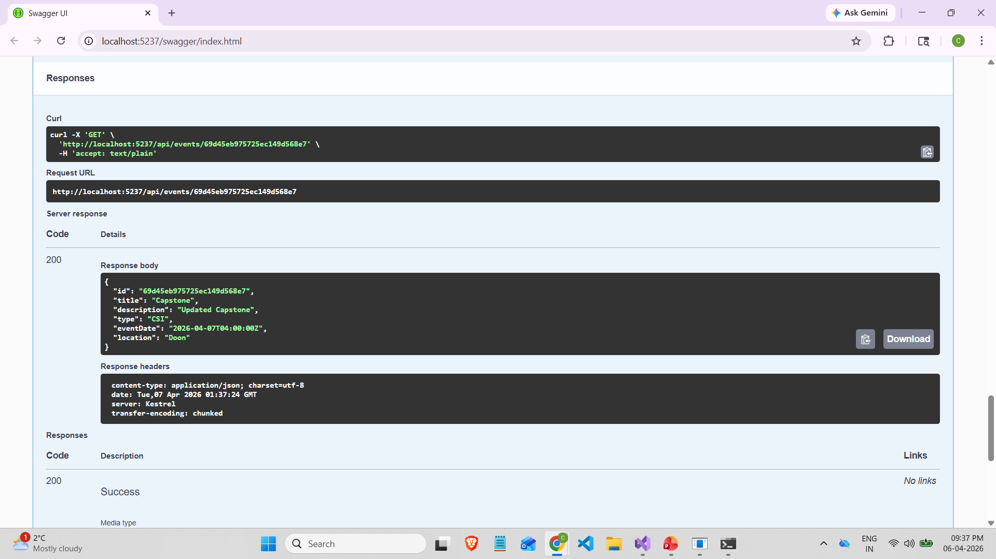
PUT/ update the event based on ID
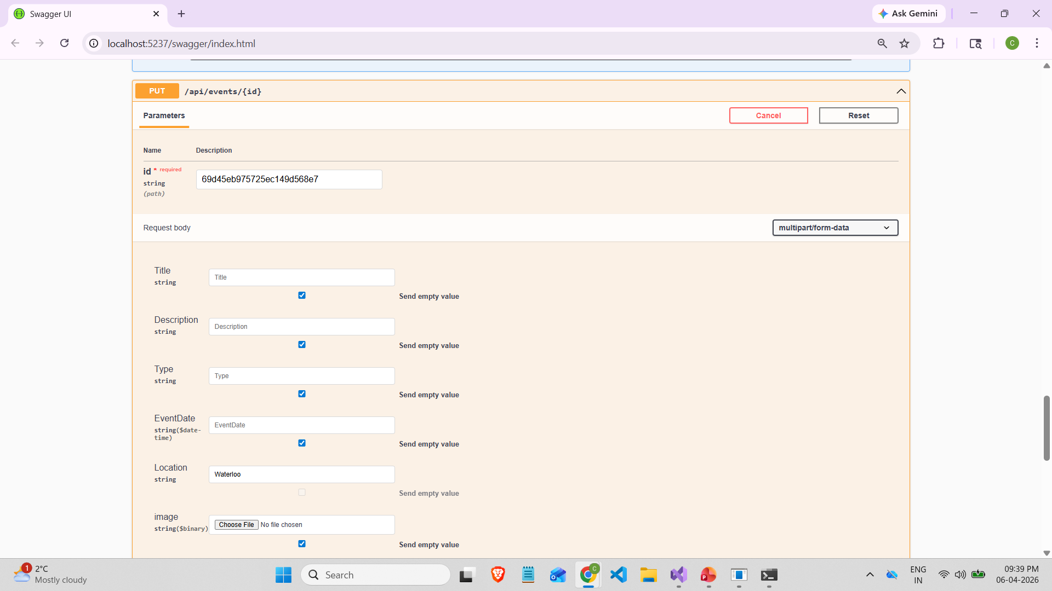

Response:
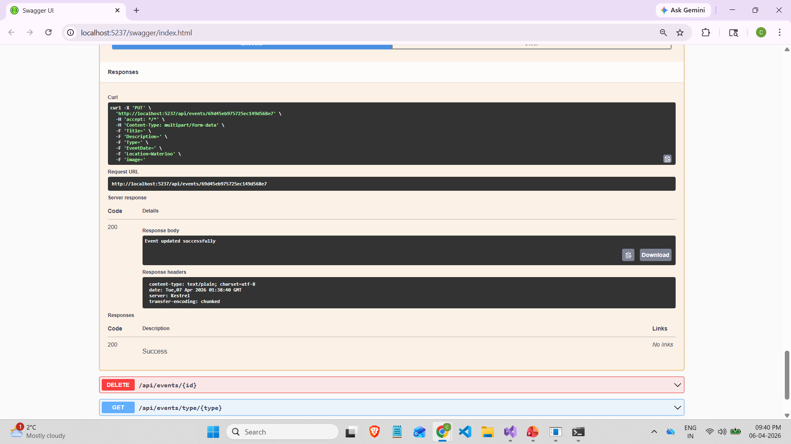

Login as a TestUser for requesting Mentorship:
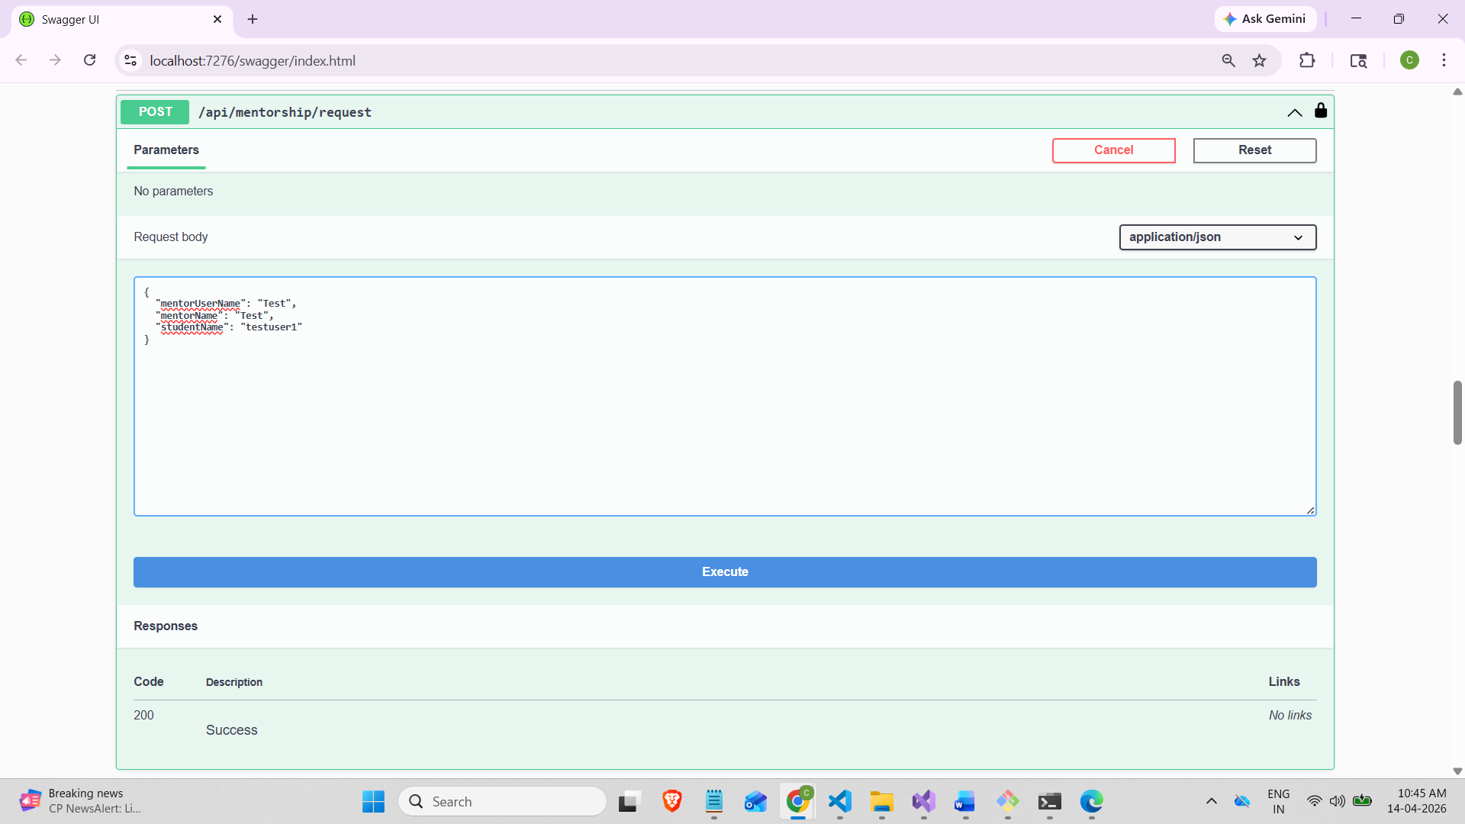

Response: Status Pending
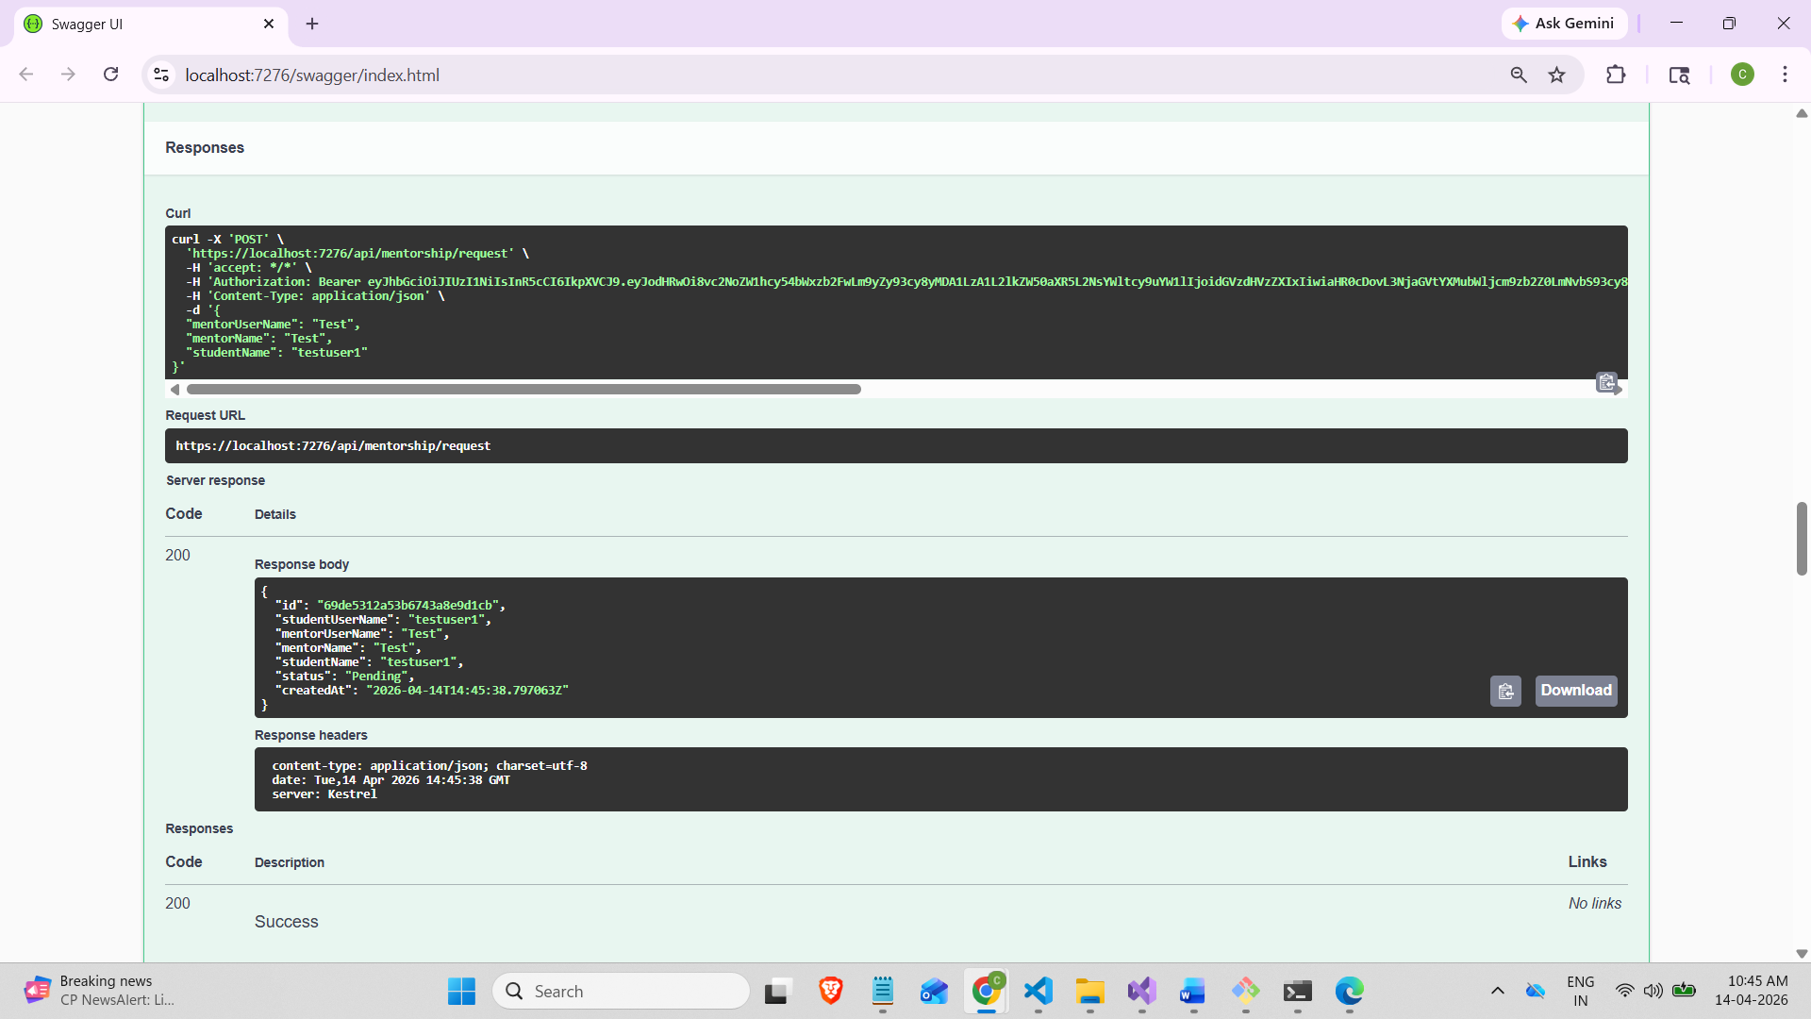

Once the Alumni userName: Test, Accept the Request, Then status will change to approved.

Now, I’m logging into alumni account to accept the request

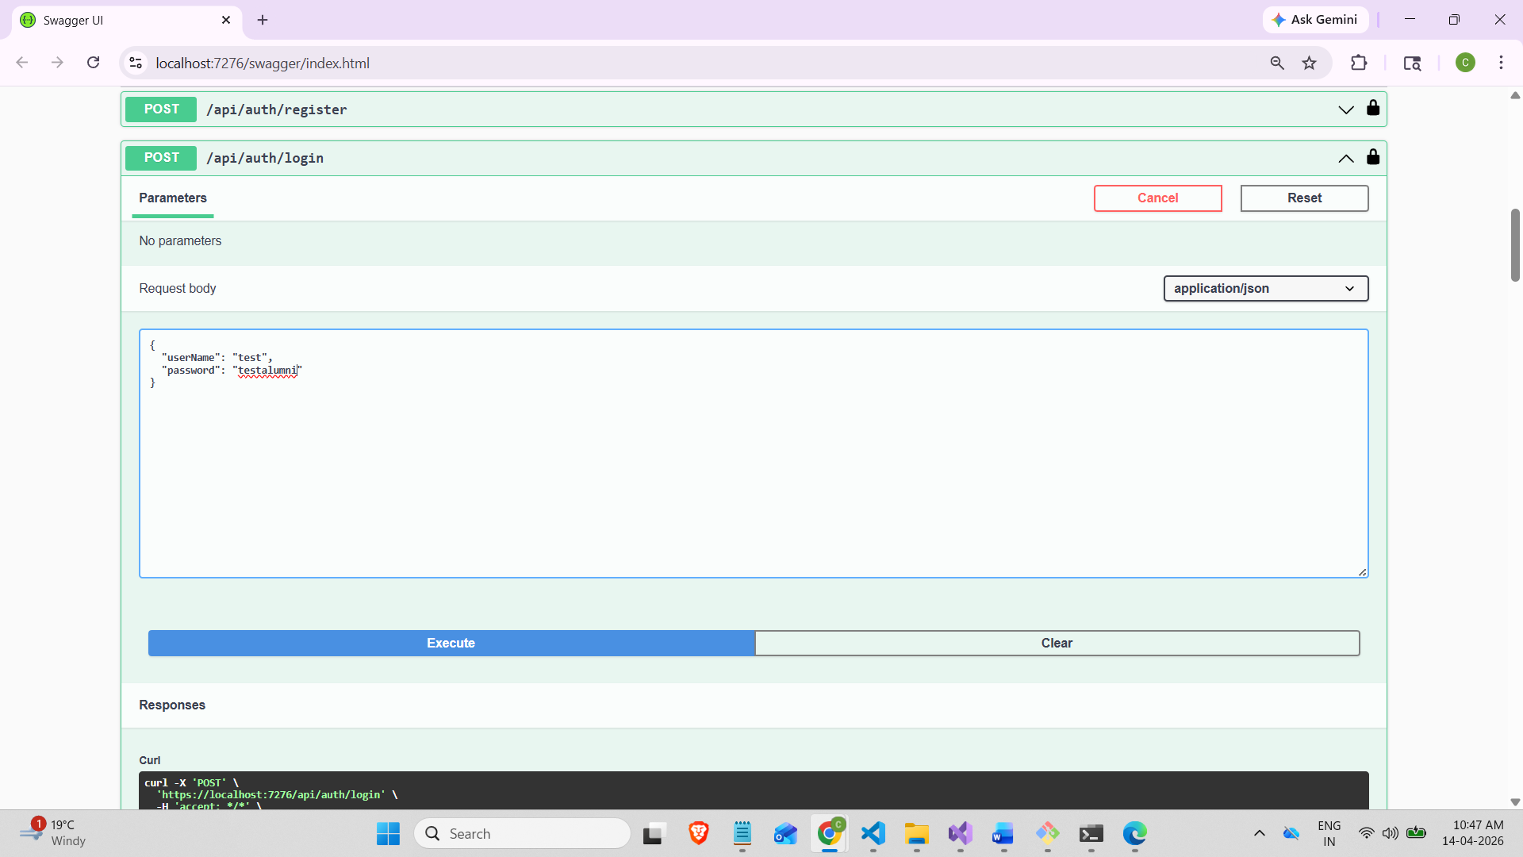

PATCH/api/mentorship/{id}/accept:

Added request users ID to accept:
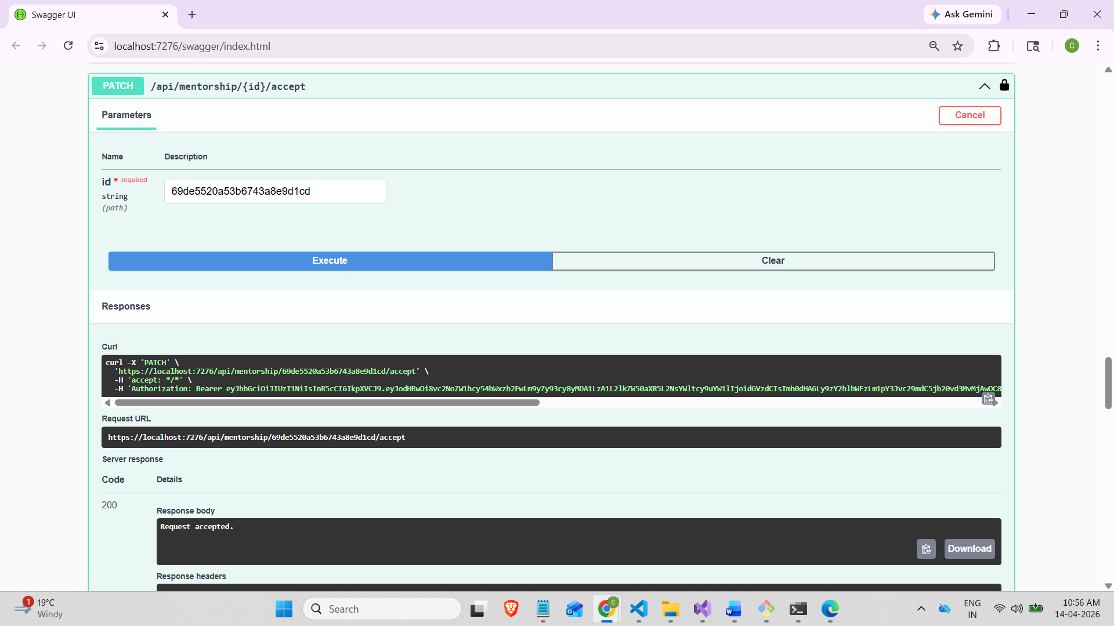

After Alumni Accept:
When we login as a student username: testuser1
We can see the status changed from pending to accepted.

